Epsom & Ewell F.C.
7
v
North Greenford United
Saturday, 28th October 2017 – 3.00 p.m.
Good afternoon and welcome to High Road for our first League match here for five weeks! We welcome the players, supporters and officials of North Greenford United and wish them a safe journey home.

We last met our opponents in the final league match of last season, when we secured a narrow 3-2 win. It is concerning that we have not recorded a League win since that day, although recent results have provided us with some optimism that we will be climbing the table soon!

We last played here against Hanworth Villa on 23rd September, drawing 1-1. At the time it was by some distance our best performance of the season and on another day we might have won it. However, we followed this up by crashing out of the League Cup 4-2 at Worcester Park and then we lost for the first ever time in five visits to Knaphill by six goals to two.

Two weeks ago we visited Camberley Town where we secured a 1-1 draw, despite making the journey with just twelve players. New signing Lloyd Connolly from Westfield headed our equaliser, shortly after we had gone behind and we were worth a point for a fine defensive display.

Then last Saturday we made our first ever visit to Rusthall for our F.A.Vase encounter where we witnessed a most incredible win by seven goals to two. They did have a player dismissed in the first half which we took full advantage of, but we were already ahead by that point and once Reisse Griffin had scored following a SEVENTY yard run out of defence with the ball their resistance was broken and we ran away with it.

The Second Round draw sends us to Whitstable Town for the first time since 1954 when we had a pair of F.A. Cup meetings. This replaces the home League match on 11th November against Godalming Town which will now be played on Tuesday 21st. This means we are now not at home again until we host Farnham Town on Tuesday 14th November! We visit Chertsey Town this Tuesday and follow that up with a trip to Bedfont Sports on Saturday before heading to Kent.

Please note that we have now combined the match sponsorship into one item at £60. This still includes free entry for three people, including programmes and hospitality and in a new initiative you get to choose the player of the match, which will result in a prize for that player. Alternatively, you can sponsor a player at £40 a time, so please help our club by letting a Committee member know. The new list of players is available in today’s programme.

Finally, don’t forget that the Super Six is running at an all-time high with a current jackpot of £630!! Why not have a go, or maybe two. This is quite a sizeable prize now!

Enjoy the game.

Rich

Don’t forget, you can follow us on Facebook: www.facebook.com/epsomandewellfc
Twitter: @EEFCOfficial Instagram at: www.instagram.com/epsomandewellfc
and Youtube at: www.youtube.com/channel/UCtLrpS0x5OaYUACRT34_zng

Cover photos by Gemma Jarman

- Alex McKay celebrates his birthday this week by scoring our fifth goal at Rusthall

- Kyle Hough scores our second goal at Knaphill. Our first is viewable on Instagram!

Cherry Red Records Combined Counties League
Premier Division Table 2017/18
inc Tuesday 24th Oct | P | W | D | L | F | A | Pts | GD | H | A
Westfield | 12 | 10 | 1 | 1 | 46 | 12 | 31 | +34 | 14/4 | 9/12
Walton & Hersham | 14 | 9 | 2 | 3 | 28 | 14 | 29 | +14 | 30/12 | 21/4
Bedfont Sports | 13 | 8 | 2 | 3 | 36 | 23 | 26 | +13 | 24/3 | 4/11
Horley Town | 12 | 8 | 0 | 4 | 23 | 18 | 24 | +5 | 2-3 | 23/12
Spelthorne Sports | 13 | 7 | 2 | 4 | 29 | 20 | 23 | +9 | 1-5 | 27/1
Sutton Common Rovers | 12 | 7 | 2 | 3 | 21 | 13 | 23 | +8 | 3/2 | 0-5
Guildford City | 12 | 7 | 0 | 5 | 18 | 14 | 21 | +4 | 2/12 | 7/4
Redhill | 14 | 5 | 3 | 6 | 27 | 22 | 18 | +5 | 0-5 | 6/1
Hanworth Villa | 13 | 4 | 6 | 3 | 21 | 21 | 18 | 0 | 1-1 | 10/2
Colliers Wood United | 14 | 5 | 2 | 7 | 28 | 26 | 17 | +2 | 30/3 | 2-5
CB Hounslow United | 11 | 4 | 3 | 4 | 19 | 15 | 15 | +4 | 13/2 | 2-4
North Greenford United | 12 | 3 | 6 | 3 | 19 | 19 | 15 | 0 | 28/10 | 17/3
Knaphill | 11 | 4 | 3 | 4 | 24 | 26 | 15 | -2 | 24/2 | 2-6
Camberley Town | 12 | 3 | 6 | 3 | 16 | 18 | 15 | -2 | 10/3 | 1-1
Balham | 10 | 4 | 2 | 4 | 15 | 19 | 14 | -4 | 20/1 | 25/11
Abbey Rangers | 12 | 4 | 2 | 6 | 15 | 21 | 14 | -6 | 16/12 | 17/2
Banstead Athletic | 12 | 3 | 4 | 5 | 15 | 20 | 13 | -5 | 2/4 | 1-1
Farnham Town | 11 | 3 | 3 | 5 | 16 | 23 | 12 | -7 | 14/11 | 0-0
Chertsey Town | 13 | 3 | 2 | 8 | 21 | 32 | 11 | -11 | 2-7 | 31/10
AFC Hayes | 11 | 3 | 1 | 7 | 14 | 21 | 10 | -7 | 28/4 | 18/11
Godalming Town | 13 | 1 | 4 | 8 | 14 | 34 | 7 | -20 | 11/11 | 13/1
Epsom and Ewell | 12 | 0 | 4 | 8 | 14 | 43 | 4 | -29 | X | X
1

Lucky Day? – 28th October
Played 15 - Won 3 Drawn 3 Lost 9 - For 25 Against 29 - PPG 0.80 - Very Poor
Our Club record against today’s opponent
Played 12 - Won 4 Drawn 2 Lost 6 - For 18 Against 22 - PPG 1.17 - Poor
Our Largest wins and losses against today’s opponent
19th April 2008 - W 3-0 - Combined Counties League (H)
1st November 2008 - L 1-4 - Combined Counties League (A)
Their Last Visit
28th April 2017 - Won 3-2 - Combined Counties League

Results and Fixtures so far
F.A. Vase Second Qualifying Round – Friday 22nd September
AC London | 0-5 | Horley Town
F.A. Vase Second Qualifying Round – Saturday 23rd September
Balham | 5-0 | Forest Hill Park
Buckingham Athletic | 1-0 | AFC Hayes
Deal Town | 2-1 | CB Hounslow United
Godalming Town | 3-5 | Brockenhurst
Hassocks | 0-3 | Spelthorne Sports
K Sports | 4-2 | Abbey Rangers
Knaphill | 0-2 | Horndean
Sporting Club Thamesmead | 0-8 | Walton & Hersham
Warminster Town | 0-4 | Farnham Town
Combined Counties League – Saturday 23rd September
Banstead Athletic | 3-2 | Chertsey Town
Epsom & Ewell | 1-1 | Hanworth Villa
Guildford City | 3-2 | Bedfont Sports
Redhill | 5-2 | Colliers Wood United
F.A. Vase Second Qualifying Round – Sunday 24th September
Chippenham Park | 0-2 | Camberley Town
Combined Counties League Cup 1st Round – Tuesday 26th September
CB Hounslow United | 5-2 | Eversley & California
Combined Counties League – Tuesday 26th September
Banstead Athletic | 1-0 | Guildford City
Camberley Town | 1-1 | Walton & Hersham
Horley Town | 3-1 | Colliers Wood United
Knaphill | 2-2 | North Greenford United
Redhill | 3-0 | Farnham Town
Combined Counties League Cup 1st Round – Saturday 30th September
Staines Lammas | 2-2+ | Chertsey Town
Chertsey Town won 4-3 on penalties
Worcester Park | 4-2 | Epsom & Ewell
Combined Counties League – Saturday 30th September
AFC Hayes | 1-3 | Knaphill
Bedfont Sports | 1-4 | Horley Town
Camberley Town | 0-2 | Abbey Rangers
CB Hounslow United | 1-2 | Guildford City
Colliers Wood United | 1-2 | Spelthorne Sports
Farnham Town | 3-3 | Banstead Athletic
Godalming Town | 1-3 | Walton & Hersham
Hanworth Villa | 1-1 | Balham
North Greenford United | 2-1 | Redhill
Sutton Common Rovers | 2-1 | Westfield
Combined Counties League Cup 2nd Round – Tuesday 3rd October
Bedfont Sports | 6-1 | Farleigh Rovers
Combined Counties League – Tuesday 3rd October
Godalming Town | 2-2 | Camberley Town
Results and Fixtures so far
Combined Counties League – Tuesday 3rd October
Hanworth Villa | 1-1 | Knaphill
Walton & Hersham | 0-3 | Guildford City
Combined Counties League Cup 2nd Round – Wednesday 4th October
Cove | 0-1 | Sutton Common Rovers
Combined Counties League – Friday 6th October
Colliers Wood United | 1-2 | Sutton Common Rovers
Combined Counties League – Saturday 7th October
AFC Hayes | 2-1 | Balham
Abbey Rangers | 2-3 | Hanworth Villa
Banstead Athletic | 2-2 | Godalming Town
Chertsey Town | 1-1 | CB Hounslow United
Guildford City | 2-3 | Farnham Town
Horley Town | 3-2 | North Greenford United
Knaphill | 6-2 | Epsom & Ewell
Redhill | 1-1 | Bedfont Sports
Spelthorne Sports | 1-1 | Camberley Town
Combined Counties League Cup 2nd Round – Tuesday 10th October
Abbey Rangers | 1-3 | FC Deportivo Galicia
AFC Hayes | 0-1 | Cobham
Bagshot | 1-4 | North Greenford United
Banstead Athletic | 0-3 | Farnham Town
Bedfont & Feltham | 0-1 | Godalming Town
CB Hounslow Utd | 1-2+ | Worcester Park
Chertsey Town | 1-0 | Horley Town
Chessington & Hook United | 5-2 | Sheerwater
Knaphill | 3-1 | Guildford City
Spelthorne Sports | 5-1 | Ash United
Walton & Hersham | 6-1 | Badshot Lea
Combined Counties League Cup 2nd Round – Wednesday 11th October
Colliers Wood United | 4-1 | Balham
Kensington Borough | 4-3 | Raynes Park Vale
Combined Counties League – Saturday 14th October
Balham | 3-2 | Knaphill
Bedfont Sports | 5-3 | Colliers Wood United
Camberley Town | 1-1 | Epsom & Ewell
CB Hounslow United | 1-0 | Redhill
Farnham Town | 1-0 | Abbey Rangers
Godalming Town | 1-2 | AFC Hayes
Hanworth Villa | 2-1 | Banstead Athletic
Horley Town | 0-2 | Walton & Hersham
North Greenford United | 3-1 | Guildford City
Sutton Common Rovers | 2-1 | Chertsey Town
Westfield | 2-1 | Spelthorne Sports
Surrey Senior Cup – Tuesday 17th October
Knaphill | 1-2 | Met Police
Results and Fixtures so far
Combined Counties League Cup 2nd Round – Tuesday 17th October
Redhill | 9-0 | Fleet Spurs
Combined Counties League – Tuesday 17th October
Abbey Rangers | 1-1 | Sutton Common Rovers
Walton & Hersham | 1-3 | Westfield
Combined Counties League – Friday 20th October
Bedfont Sports | 6-1 | Chertsey Town
F.A. Vase First Round – Saturday 21st October
Balham | 1-3 | Deal Town
Cobham | 0-4 | Westfield
Edgware Town | 1-3 | Walton & Hersham
Erith & Belvedere | 2-2+ | Horley Town
Farnham Town | 2-0 | Lymington Town
Hanworth Villa | 3-2 | Three Bridges
Haywards Heath Town | 2-0 | Camberley Town
Rusthall | 2-7 | Epsom & Ewell
Spelthorne Sports | 0-1 | Lordswood
Surrey Senior Cup – Saturday 21st October
Guildford City | 2-2 | Colliers Wood United
Colliers Wood United won 5-3 on penalties
Combined Counties League – Saturday 21st October
Abbey Rangers | 1-3 | North Greenford United
AFC Hayes | 0-3 | CB Hounslow United
Redhill | 1-1 | Banstead Athletic
Sutton Common Rovers | 3-0 | Godalming Town
F.A. Vase First Round Replay – Tuesday 24th October
Horley Town | 3-2+ | Erith & Belvedere
Surrey Senior Cup – Tuesday 24th October
Dorking Wanderers | 4-1 | Walton Casuals
Westfield | 3-2 | Abbey Rangers
Combined Counties League – Tuesday 24th October
Chertsey Town | 1-4 | Spelthorne Sports
Walton & Hersham | 1-0 | Bedfont Sports
Combined Counties League – Saturday 28th October
Abbey Rangers | V | CB Hounslow United
AFC Hayes | V | Sutton Common Rovers
Banstead Athletic | V | Westfield
Colliers Wood United | V | Camberley Town
Epsom & Ewell | V | North Greenford United
Farnham Town | V | Horley Town
Godalming Town | V | Chertsey Town
Redhill | V | Hanworth Villa
Spelthorne Sports | V | Bedfont Sports
Walton & Hersham | V | Balham
Combined Counties League – Tuesday 31st October
Chertsey Town | V | Epsom & Ewell

From behind the goal
Epsom & Ewell 1-1 Hanworth Villa
Combined Counties League - Premier Division - Saturday 23rd September 2017

Best performance of the season earns our first home point

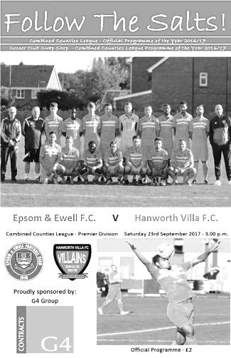
Although the record for the season shows that we still await our first win in the eleven matches played, this performance against one of the traditionally better sides in the division gave me the belief that we can get out of the position we currently find ourselves in, as we held our own for the full ninety minutes and on another day might even have pinched the win.

As usual we were forced into changes after last week's draw at Farnham, although there were just the two this time. Up front Sean White came into the starting line-up in place of the unwell Joe Loftus-Cheek, while in place of the absent Colin Harris we were able to call on Conor Young, who had played for us once before in 2015 as cover for our regular keeper Michael Eacott. This time he would find big Mike at the other end, playing for the opposition instead, following his summer departure.

Also playing against us was another former Salt, Tom Neale and it was pleasing to note that we kept him fairly quiet this time, after failing to do so last season. In fact Neale was very fortunate to escape with a warning for a late challenge on Young when the match was just five minutes old.

We might have been a goal up by then as the first of eight Epsom corners in the first half was delivered straight through the penalty area to the far post in the second minute where Ashley Thompson forced Eacott into a very good save, clawing the ball away. However, we took the lead anyway in the 13th minute when Jason Nwachukwu got down the left flank and although his cross was half cleared, the ball fell to Liam Roberts who cleverly fed the ball through to White who finished clinically. There were appeals for offside from the visitors, but I was right in line at the moment it was played and the back line was all over the place with White most definitely onside.

Seeing the back line like that gave me hope that we could take advantage of this frequently, but it never quite turned out like that and within four minutes they were level as the lightning fast Cyril Ocansey ran round Adam Heagney on the left wing and delivered a low cross that was buried past Young by Levi King from eight yards out.

Heagney and Jamie Hatfield on the left were finding their hands full as both wingers really tested us, but they managed and the threat decreased as the match went on. The two teams traded long range strikes on target before Rob Hendry set Nwachukwu through on the left but he chose to try and beat Eacott at the near post with White

waiting and the save was made. Further corners followed but we were given a sharp reminder of the opposition threat as Ocansey broke away on the counter attack from one of our set pieces. Fortunately Reisse Griffin and Young managed to break up the threat at the last minute.

In the 39th minute we were extremely unfortunate when Heagney took a free kick from nearly thirty yards that caught Eacott out and flew back into play off the Hanworth crossbar. The ball then hit Dale Marvell before he could react to it and the danger was cleared. Marvell's next attempt after a good run went over the bar from outside the area but we were again caught out on the break soon after as Ocansey's shot was weak and easily gathered by Young just before the half time whistle blew.

In our last home match against Horley we had gone in level at half time only to be caught out right at the start of the second half and it so nearly happened again within sixty seconds when Young went to claim a free kick from the right hand side but was nowhere near it. Fortunately the header at goal just cleared the bar. In the 49th minute King thought he had a second goal, only to be denied by the Assistant's flag before Neale got away from Griffin and drove a powerful shot at Young who blocked the shot and recovered to palm the loose ball away just before King reached it.

The attacks on our goal became fewer though and next to showcase his skills on the hour mark was Roberts who got away on the right before twisting and turning his defender inside out before shooting at goal, only to see the ball hit a defender near the goal line and rebound straight to Eacott who was on the ground by then. A few minutes after this another Heagney free kick from an angle was missed by everyone, and at the far post Scott Murphy got a touch to the ball only to see it cleared off the goal line.

As the game moved into the final stages substitute Tayo Ajayi came on and had two good chances to win the match. His first shot took a slight deflection which made it a lot easier for the grateful Eacott to reach but in the 86th minute White put him through on goal, although with Roberts waiting he chose to shoot and Eacott made a good block with the ball falling to White but his shot was blocked, again with Roberts waiting in space. As we began to wonder whether these missed chances would come back to haunt us, we nearly found out the hard way as Hanworth Villa nearly pinched the points from a corner, but the header just cleared our bar and the match finished even.

Without a doubt this was our best performance of 2017/18 and for the first time this season I can honestly say that I thought we were the better side over the ninety minutes. The visitors had their moments of course, but if we can continue to produce like we did in this match, we can definitely start to climb the table once we get back into the league schedule in two weeks, following our League Cup tie at Worcester Park next Saturday.

Epsom and Ewell: Conor Young, Adam Heagney, Jamie Hatfield (c), Scott Murphy, Reisse Griffin, Jason Nwachukwu, Dale Marvell, Ashley Thompson, Rob Hendry, Sean White, Liam Roberts

Subs: Tayo Ajayi for Hendry (74), Cristian Castell for Roberts (92)

From behind the goal
Worcester Park 4-2 Epsom & Ewell
Combined Counties League Cup - First Round - Saturday 30th September 2017

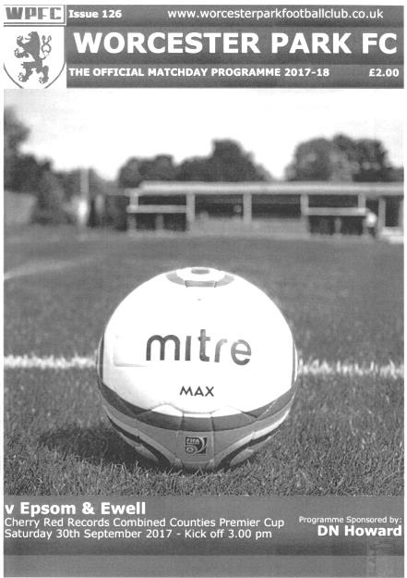
League Cup disaster as Salts collapse at Worcester Park

In the grand scheme of things this season, the League Cup was probably very low on our list of priorities, but following two draws this was the ideal opportunity to build on that by registering our first win of the season and we blew it massively.

The winners of this tie at Green Lane would go on to visit the new Green Lane home of CB Hounslow United in the next round. On our earlier visit there this season we took the lead with a fine solo goal, and scored the final goal of the match but conceded four times in between, and at Worcester Park the story was an identical one.

Once again further changes were required to the line-up after our encouraging 1-1 draw with Hanworth Villa last week. Colin Harris was back in goal for the absent Conor Young, while Alex McKay made his first start of the season in place of Reisse Griffin who was also away. In midfield Ben Dyson came in for Jason Nwachukwu, while up front Kyle Hough was away and although Joe Loftus-Cheek was over his illness, he started on the bench with Rob Hendry and Sean White keeping their places after last week.

Another player who kept his place was Liam Roberts and deservedly so. He provided the spark in the early stages of the match and scored a superb opener in the 12th minute. We had started well, pressuring the home side down the hill with some admittedly fairly direct stuff, and a deep crossfield ball set Sean White off down the left, but he was forced wide. He laid the ball back for Roberts on the touchline from where he cut in, beat two men and drilled a low shot beyond the dive of the Worcester Park keeper.

It was just the start we needed after two draws in our previous matches and Rob Hendry nearly made it two-nil but was unable to get Ben Dyson's good cross on target with a header just over the bar. White then beat the offside trap but with the advancing keeper to pass, he was unable to get a toe to the ball that would surely left him to walk the ball in. Approaching the half hour Dyson found White but he sliced his shot horribly wide from a good position. Unfortunately these missed chances would come back at us later.

In fact, we had already survived some close calls with Harris alert to block a low strike on the turn from eight yards out, while Adam Heagney had to clear the ball out from under the crossbar soon after this. Another good ball fizzed across and through our six yard box just

ahead of a striker before a near post delivery was flicked wide. The equaliser was coming.

But before it did, there was an odd incident at the other end when Roberts got to the ball ahead of the keeper who knocked the ball away with his hand. The referee thought that the incident had taken place outside the area and blew for the free kick. Even from behind the goal you could tell that it had happened inside the area but I'll admit, once that whistle blew I thought there would be an early bath to follow. Fortunately for the home team the referee chose to consult with the Assistant who had waited quietly on the touchline, and after discussion the drop ball was rightly awarded.

From an Epsom standpoint this was unfortunate. With so little going our way so far this season it was the sort of break we could have done with, but within moments Worcester Park were level when the ball was fed out to their right back who had an enormous amount of space. He strolled up the park and then planted a cross onto the head of Joe Cheeseman who found the corner of the net in the 35th minute.

The home team grew in confidence and kept pushing us back. I was hoping that we could hold out until half time and reorganise but it was not to be as Mark Waters unleashed a twenty yarder into the roof of the net in first half injury time and the players trooped off very low on spirits shortly afterwards.

The second half started awfully. Ashley Thompson made a last minute interception, sending the ball just over his own crossbar. Admittedly though, if he hadn't got to the ball it would have left an easy finish. However, we didn't heed the warning and a close range header was sent just wide of our post before the lead was extended in the 50th minute with an easy finish at the far post after they cut us apart down the left and sent a low delivery in. Bad became worse when another dangerous delivery was diverted into our net by McKay, but again with strikers waiting, our man had no chance but to play the ball.

At 4-1 down the match had ended as a contest and brought back reminders of earlier collapses. It could have got worse as we pushed up and were caught on the break but the striker put his shot just wide of our post with only Harris to beat. We reduced the deficit with a nice move in the 66th minute that was set up by White and finished off from close range by Hendry, but to extend the connection with the two players surnames, we needed snookers by that point and although Dale Marvell was unlucky to see his shot hit the post soon after, it required two good saves from Harris to keep the score as it was.

This was an extremely disappointing display, especially when considering how good the start of the match had been. I could see no way at that point that things could go so badly wrong against a team that appeared similarly limited and equally vulnerable defensively. However, performances like this will see us playing a lot more Step Six sides in the not too distant future and we have to step things up considerably for our important League trip to Knaphill next week if we are to avoid this. We may not have lost any points this week, but we lost the momentum that we had been building up and have to face the fact that we are now involved in a very challenging relegation battle and find a way out of it quickly.

Epsom and Ewell: Colin Harris, Adam Heagney, Jamie Hatfield (c), Scott Murphy, Alex McKay, Ben Dyson, Ashley Thompson, Dale Marvell, Rob Hendry, Sean White, Liam Roberts

Subs: Joe Loftus-Cheek for Dyson (71), Tayo Ajayi for Roberts (84)

From behind the goal
Knaphill 6-2 Epsom & Ewell
Combined Counties League - Premier Division - Saturday 7th October 2017

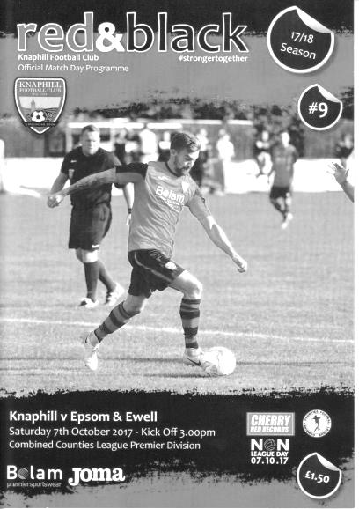
Season reaches crisis point after second half collapse

If we weren't before, we are definitely now in serious relegation trouble following this heavy defeat at Knaphill; our first in five visits to Redding Way.

Despite the return of Kyle Hough up front, Bentley Graham in midfield and speedy Reisse Griffin at the back, we were still unable to deal with the home side when they attacked and their return of six goals from less than a dozen chances was equally concerning, when you consider that they also hit the bar twice.

The absence of Glyn Mandeville, called away for work, ensured a first match in charge for our new Assistant Manager Alex McKay, but he only had a squad of 15 players to select from out of the 32 we currently have registered. Our keeper Colin Harris was injured and so Conor Young came in for his second appearance of the season, following his good performance at home to Hanworth Villa two weeks previously and played well when called upon, with little chance of saving many of the goals.

The afternoon started badly as we were behind in the 6th minute. A long throw from the left landed at the feet of Jacob McDonald and he turned Scott Murphy and drilled the ball low past Young in one movement from just eight yards. However, we were on level terms four minutes later when a long ball into the danger area from Ben Dyson was reached by a stretching Ashley Thompson who managed to lift the ball over the long-serving Richard Shelley in the Knaphill goal from 12 yards out to register his first goal for the club.

The game then settled into a pattern for the rest of the half with our game being fairly direct in an attempt to find Hough, Liam Roberts or Sean White, operating on the flanks, as was the case at Worcester Park previously. It nearly worked straight away as Roberts drilled the ball deep from the left wing to where White had pulled away at the far post, but his header went back across Shelley and beyond the other post.

We had a scare when their Captain Jimmy Norman tried his luck from 25 yards and saw his shot come back off the cross bar but we didn't heed the warning and in the 26th minute Young was caught out by his lack of match fitness and clumsily brought down a

striker in the box, earning a yellow card in the process. Norman tucked away the subsequent penalty and we nearly conceded again moments later when a Timmy Taylor strike was blocked on the goal line by Murphy.

Knaphill nearly conceded in the 34th minute when Shelley let a back pass go under his foot, just recovering to concede the corner but then followed an error by the otherwise excellent referee as Shelley went over to the ball and picked it up, denying us the opportunity of the quick corner while their players were hurrying back to defend. This should have been a mandatory yellow card. However, the half finished 2-1 to the home side, and it was hard to argue with this as they had held the ball for longer than us.

What followed was frighteningly reminiscent of the previous week's League Cup defeat as we conceded twice soon after the restart. Young was unlucky with the first of these in the 48th minute as a powerful 20 yard shot from Ross Cheek seemed to take a strange hop over his dive, but we were totally the architects of our own downfall for the next. Jamie Hatfield threw the ball back to Young whose attempted clearance was half charged down by a striker, who retrieved the loose ball and fired it into the danger area, where Griffin got to it first, sending it flying towards Young's net, where he made a superb save for a corner! The reward for this was precisely nothing as the set piece was headed in to our net by Rob Parrott, who was six yards out and didn't even have to jump.

The goal came in the 55th minute and six minutes later Parrott repeated the trick with another header from a left wing free kick. This was frankly embarrassing to watch and maybe even the referee felt sorry for us as he awarded us a penalty for a handball, when a shot on goal was blocked by a defender a good yard or two outside their area. Kyle Hough put the penalty away, giving Shelley no chance whatsoever in the 67th minute and their keeper injured his knee shortly afterwards as he fell awkwardly and had to be replaced by Aaron Bufton.

Despite this, it was the home team that rounded off the scoring in the 78th minute moments after they had hit the bar, when Connor Blanchard forced in a loose ball from what looked to me like a very clear offside position. In fairness though, it didn't have any bearing on the result which had been decided long ago and even Hough's injury time attempt at a grandstand finish with a clever chip was denied as Bufton clawed the effort around the post.

This was our fifth defeat this season by four goals or more. The last time this happened was in our last relegation season of 2003/04, and even then we had only suffered two defeats of that size by this stage of the season. With a traditionally difficult match to Camberley Town up next, the task doesn't get any easier. If a few more of our players were available in the first place it would help!

Epsom and Ewell: Conor Young, Ben Dyson, Jamie Hatfield (c), Reisse Griffin, Scott Murphy, Ashley Thompson, Sean White, Dale Marvell, Bentley Graham, Kyle Hough, Liam Roberts

Subs: Louis O'Brien for Roberts (56), Dan Rose for Dyson (67)

Ryman League Division One South Table
incl Saturday 21st October | P | W | D | L | F | A | Pts | GD
Lewes | 14 | 10 | 3 | 1 | 30 | 11 | 33 | +19
Sittingbourne | 13 | 8 | 4 | 1 | 26 | 11 | 28 | +15
Corinthian-Casuals | 14 | 9 | 1 | 4 | 26 | 15 | 28 | +11
Cray Wanderers | 13 | 7 | 5 | 1 | 25 | 9 | 26 | +16
Whyteleafe | 14 | 7 | 5 | 2 | 27 | 14 | 26 | +13
Greenwich Borough | 13 | 7 | 4 | 2 | 27 | 14 | 25 | +13
Carshalton Athletic | 13 | 7 | 3 | 3 | 28 | 22 | 24 | +6
Walton Casuals | 14 | 6 | 5 | 3 | 29 | 21 | 23 | +8
Hythe Town | 14 | 7 | 2 | 5 | 24 | 16 | 23 | +8
South Park | 12 | 6 | 2 | 4 | 29 | 20 | 20 | +9
Phoenix Sports | 12 | 5 | 3 | 4 | 23 | 18 | 18 | +5
Herne Bay | 13 | 6 | 0 | 7 | 23 | 27 | 18 | -4
Thamesmead Town | 12 | 5 | 2 | 5 | 23 | 21 | 17 | +2
Hastings United | 13 | 4 | 3 | 6 | 21 | 25 | 15 | -4
Chipstead | 13 | 4 | 3 | 6 | 18 | 23 | 15 | -5
Guernsey | 14 | 5 | 0 | 9 | 17 | 28 | 15 | -11
Horsham | 13 | 4 | 2 | 7 | 17 | 26 | 14 | -9
Ramsgate | 13 | 4 | 2 | 7 | 19 | 30 | 14 | -11
Faversham Town | 14 | 4 | 1 | 9 | 18 | 22 | 13 | -4
VCD Athletic | 13 | 4 | 1 | 8 | 23 | 33 | 13 | -10
Molesey | 13 | 4 | 1 | 8 | 21 | 32 | 13 | -11
East Grinstead Town | 13 | 2 | 3 | 8 | 19 | 32 | 9 | -13
Ashford United | 13 | 2 | 2 | 9 | 11 | 29 | 8 | -18
Shoreham | 13 | 2 | 1 | 10 | 12 | 37 | 7 | -25
The season may still be early but Lewes look well set for a return to the top flight this year, despite a narrow midweek loss. A convincing 8-1 win over Herne Bay on Saturday has enabled them to open a gap over second placed Sittingbourne who required a 90th minute equaliser to salvage a point from a 1-1 home draw with Chipstead.

In the play-off positions both Corinthian Casuals and Cray Wanderers are regular challengers now with Whyteleafe making up the final position at present. However, Manager Leigh Dynan has just left the club to take over at Kingstonian so it will be interesting to see what happens here.

At the other end, Shoreham drop back to the bottom after East Grinstead Town’s midweek win over Carshalton Athletic. The team to watch here from an Epsom point of view though are Molesey. In our position we cannot afford to have a team in our catchment area dropping down from Step Four, so it is imperative that someone else finishes at the foot of the table this season.

Our landlords look fairly solid this season so far and if not for a couple of late equalisers against them, they would be higher still.

Combined Counties League Division One Table
incl Saturday 21st October | P | W | D | L | F | A | Pts | GD
Eversley & California | 13 | 10 | 0 | 3 | 44 | 26 | 30 | +18
Sheerwater | 12 | 9 | 2 | 1 | 39 | 16 | 29 | +23
Worcester Park | 12 | 9 | 2 | 1 | 42 | 22 | 29 | +20
Staines Lammas | 10 | 8 | 0 | 2 | 30 | 12 | 24 | +18
AC London | 12 | 8 | 0 | 4 | 28 | 15 | 24 | +13
Raynes Park Vale | 12 | 7 | 0 | 5 | 35 | 24 | 21 | +11
Cobham | 9 | 6 | 2 | 1 | 33 | 11 | 20 | +22
FC Deportivo Galicia | 10 | 5 | 1 | 4 | 26 | 18 | 16 | +8
Chessington & Hook Utd | 12 | 5 | 1 | 6 | 28 | 30 | 16 | -2
Farleigh Rovers | 12 | 5 | 1 | 6 | 24 | 30 | 16 | -6
Frimley Green | 11 | 4 | 3 | 4 | 21 | 21 | 15 | 0
Fleet Spurs | 12 | 4 | 2 | 6 | 27 | 32 | 14 | -5
Ash United | 10 | 4 | 0 | 6 | 18 | 27 | 12 | -9
Badshot Lea | 8 | 3 | 2 | 3 | 19 | 19 | 11 | 0
South Park Reserves | 10 | 3 | 2 | 5 | 17 | 27 | 11 | -10
Cove | 12 | 2 | 2 | 8 | 16 | 31 | 8 | -15
Bagshot | 12 | 2 | 0 | 10 | 17 | 49 | 6 | -32
Kensington Borough | 11 | 1 | 2 | 8 | 14 | 32 | 5 | -18
Bedfont & Feltham | 12 | 0 | 0 | 12 | 7 | 43 | 0 | -36
A very strange situation is developing in the Division below us that could have huge repercussions in our favour.

Whilst Eversley and California lead the table, Sheerwater, Worcester Park and Staines Lammas are just behind them. However, all three of those clubs are set to be relegated at the end of the season as they do not fit the current F.A. Step Six criteria, which is to be implemented in 2018! Now, whether they are relegated or not isn’t the issue for us; the really important part is whether they would block other teams from promotion, which would mean that fewer clubs from our division could be relegated!

Our Division has to drop to twenty teams, so if two went up, let’s say Westfield and Walton & Hersham, and no one drops down from Step Four we would be at 20. This means that the usual three up and three down between the divisions would then apply, so if one or two of those clubs were unable to go up, that would surely help our cause.

Right now, this looks like it might actually happen, although Cobham are having a good season and have games in hand to catch the top teams still at this early stage.

At the foot of the table are Bedfont & Feltham, which is quite a surprise as they looked like they were turning things around last season, even though that came too late to save them from relegation. I thought they would be higher up but there is still time to salvage matters and as relegation is not happening to them, it may not prove to be too serious. Of the new clubs this season FA Deportivo Galicia appear the strongest so far, although they are not going to trouble the top teams this season.

First Eleven Appearances 2017/18 - (max 15)
Name | Debut | 2016/17 |  |  |  | Career Totals
 |  | App | Sub | Total | Goals | App | Sub | Total | Goals
AJAYI Tayo | 06/08/2017 | 3 | 4 | 7 | 1 | 3 | 4 | 7 | 1
BROOKS Jordan | 06/08/2017 | 3 | 0 | 3 | 0 | 3 | 0 | 3 | 0
CASTELL Cristian | 06/08/2017 | 2 | 4 | 6 | 0 | 2 | 4 | 6 | 0
CONNOLLY Lloyd | 14/10/2017 | 2 | 0 | 2 | 1 | 2 | 0 | 2 | 1
DEWAR Ali | 29/10/2011 | 1 | 1 | 2 | 0 | 56 | 41 | 97 | 10
DYSON Ben | 12/08/2017 | 11 | 1 | 12 | 0 | 11 | 1 | 12 | 0
GRAHAM Bentley | 09/02/2016 | 2 | 0 | 2 | 0 | 19 | 1 | 20 | 3
GRIFFIN Reisse | 08/08/2015 | 11 | 0 | 11 | 1 | 84 | 13 | 97 | 7
HARLAND-GODDARD Tom* | 06/08/2017 | 1 | 1 | 2 | 0 | 1 | 1 | 2 | 0
HARRIS Colin | 04/08/2012 | 9 | 0 | 9 | 0 | 34 | 0 | 34 | 0
HATFIELD Jamie | 11/11/2006 | 7 | 1 | 8 | 0 | 256 | 14 | 270 | 6
HAYWARD Ben | 07/03/2007 | 5 | 1 | 6 | 0 | 248 | 29 | 277 | 18
HEAGNEY Adam | 16/08/2016 | 4 | 0 | 4 | 0 | 41 | 9 | 50 | 1
HENDRY Rob | 08/08/2015 | 10 | 0 | 10 | 4 | 78 | 22 | 100 | 27
HOUGH Kyle | 14/08/2007 | 9 | 2 | 11 | 5 | 342 | 21 | 363 | 206
JARMAN Mark | 08/08/2009 | 0 | 0 | 0 | 0 | 136 | 51 | 187 | 76
LAW Franky* | 06/08/2017 | 3 | 0 | 3 | 0 | 3 | 0 | 3 | 0
LOFTUS-CHEEK Joe* | 06/08/2017 | 9 | 1 | 10 | 2 | 9 | 1 | 10 | 2
MARVELL Dale | 15/01/2000 | 11 | 2 | 13 | 0 | 280 | 51 | 331 | 86
MCKAY Alex | 20/12/2008 | 3 | 1 | 4 | 1 | 134 | 38 | 172 | 13
MURPHY Scott | 20/01/2007 | 9 | 0 | 9 | 0 | 21 | 2 | 23 | 1
MYERS Antony | 23/12/2006 | 1 | 0 | 1 | 0 | 76 | 33 | 109 | 9
NWACHUKWU Jason | 01/10/2016 | 8 | 3 | 11 | 2 | 25 | 19 | 44 | 3
O'BRIEN Louis* | 28/08/2017 | 1 | 3 | 4 | 0 | 1 | 3 | 4 | 0
ROBERTS Liam | 12/08/2017 | 6 | 5 | 11 | 1 | 6 | 5 | 11 | 1
ROBINSON Sam* | 22/10/2011 | 5 | 0 | 5 | 0 | 66 | 6 | 72 | 14
ROSE Daniel | 25/10/2016 | 7 | 2 | 9 | 1 | 9 | 7 | 16 | 1
SMITH Andy* | 25/08/2017 | 2 | 0 | 2 | 0 | 2 | 0 | 2 | 0
THOMPSON Ashley | 21/08/2017 | 10 | 1 | 11 | 3 | 10 | 1 | 11 | 3
THOMSON David | 02/09/2017 | 2 | 0 | 2 | 0 | 2 | 0 | 2 | 0
TURPIE Alistair | 31/03/2016 | 0 | 0 | 0 | 0 | 11 | 1 | 12 | 0
WHITE Sean | 02/08/2014 | 4 | 4 | 8 | 2 | 10 | 17 | 27 | 5
YOUNG Conor | 07/03/2015 | 4 | 0 | 4 | 0 | 5 | 0 | 5 | 0
* Player has left the club

Milestones & Birthdays
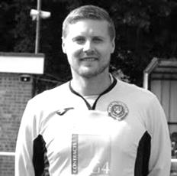
In September we had a substantial number of birthdays and we have another three this month.

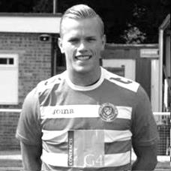
Our keeper Colin Harris celebrated his 34th birthday on 10th October. Colin joined us in August of 2012 and was our regular keeper until Christmas of that year when he suffered a horrible injury that badly damaged his hand and kept him out of football for some time. Fortunately he was able to resume his duties between the posts and he re-joined us this August. Colin has made 34 appearances for us over the two spells at our club.

On 23rd October Sean White was 22. He is another player who is in his second spell at the club, having joined us back in September 2014 and he scored twice in Glyn’s first match in charge of the club, a 4-1 win at Knaphill. However, Sean was unable to command a regular starting place and left later in the season, playing for Banstead Athletic and Walton & Hersham amongst others but he returned to us in August and has scored twice already. Currently he has 27 appearances and five goals for us.

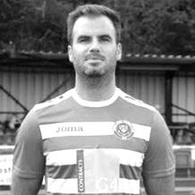
Finally, our new Assistant Manager Alex McKay was 31 on 25th October. Alex has been with the club since December 2008 and has recently joined our Hall of Fame which commemorates the 50 players with the greatest number of appearances in club history. Alex has 172 appearances and 13 goals, the most memorable of which in my opinion was a thumping last minute winning header against Windsor in April 2014, which was his second goal of the game, something he also achieved against Westfield back in August of the same season. He also scored on Saturday of course.

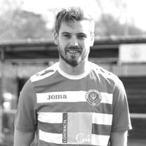
Now I move on to the milestones and on Saturday 21st October Rob Hendry became the 122nd player to reach that mark and the first since Matt Tanton. Rob is one of that rare group of players who scored on his debut at home to Windsor in August 2015. He is also the only player in club history to score for our first team away from the mainland of Great Britain, having scored twice on our trip to Chantilly.

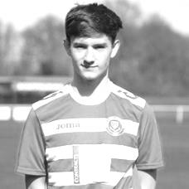
Finally for today, Adam Heagney made his 50th appearance also on Saturday, becoming the 268th person to reach that mark and the first since Jordan Gallagher last April. Adam made his debut in August 2016 at home to CB Hounslow United and was a reliable defender for us throughout the season. He took a small break at the start of the season but re-joined us in September. He has just one goal for us so far, but it was a memorable winning strike from thirty yards at Knaphill in April!

4,000 matches!
On 16th September we visited Farnham Town and in an exciting match we secured a point from a goalless draw. It was also the 4,000th Senior status match our club had played in its history.

Now in the past I have covered many of our memorable matches but this time I am going to concentrate on the milestone matches and where else to start but at the beginning!

Match 1: Epsom Town v Dorking – 30th August 1924 – Lost 1-3

Having been founded in 1918, it took us six years to work our way through the Surrey Junior League, the Sutton & District League and then the Southern Suburban League before being voted in unanimously to the Surrey Senior League. Also joining that season were Addlestone, with Chertsey Town failing to be elected.

But before that our opening match was a friendly. In those days there were many friendlies, while at the start of the season the clubs would play a trial match or two. As a result, up until 1960 our club played many friendlies that were deemed competitive fixtures in official club records, and from 1960 we started to play pre-season friendlies which are not counted in the official tally.

Our opening match was played at home, but in these pre-West Street days we were based at the Horton Hospital Sports Ground, much of which still exists today, although a lot of the old pitch now sits under Southfield Park School.

We had some of our regulars missing for this match, most notably two of our founders Ernie and Reg Sperring who were still playing cricket!

As a result we didn’t perform that well and lost 3-1 to fellow Surrey Senior League team Dorking.

Match 500: West Norwood v Epsom F.C. – 10th October 1936 – Won 3-1

On this day we were handed an away draw in the Amateur Cup against West Norwood, a very famous old club that had even played our earlier West Street inhabitants Ewell F.C. However, times were hard for them and they had no ground at the time of this encounter, so the match was moved to our ground where two goals from Bill Randall enabled us to get through to the next round.

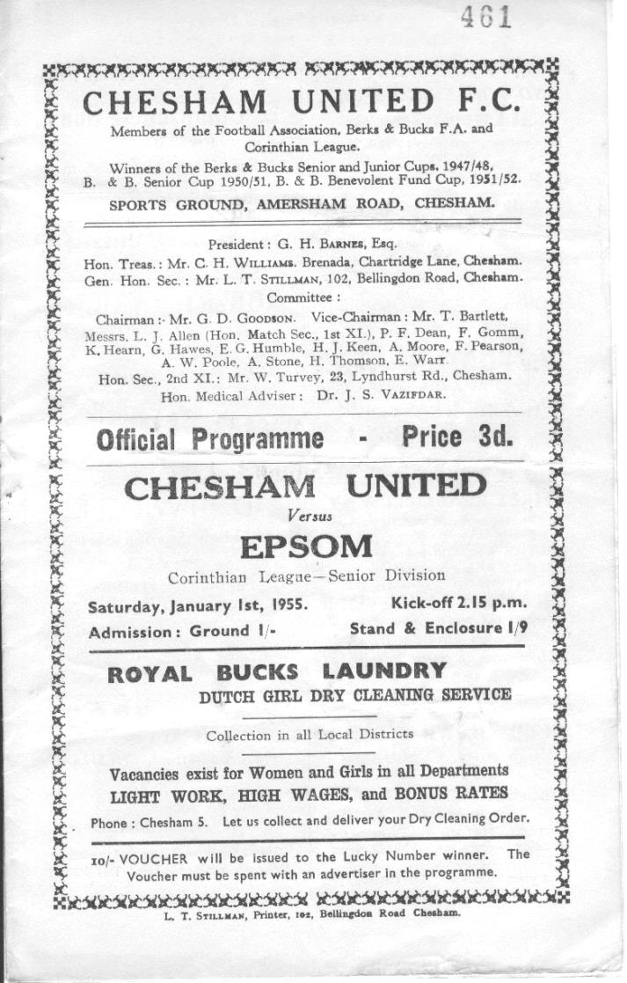
Match 1,000: Chesham United v Epsom F.C. – 1st January 1955 – Lost 1-4

Although of course nobody knew this at the time, we marked the New Year with our 1,000th match at Chesham United. However, the match didn’t go well as we crashed to a 4-1 Corinthian League defeat at the Meadow. Bobby Musto scored our goal but it was a poor season and both the First team and the Reserves were destined to finish at the bottom of the League that year.

Match 1,500: Epsom & Ewell v Eastbourne – 18th November 1967 – Won 8-1

This was a major surprise. As a very average Athenian League club in the sixties, we didn’t achieve a lot and under the Management of Dave Fillery we would finish 14th out of the sixteen clubs. However, we did finish ten points ahead of both Eastbourne and Wingate and this result illustrated that conclusively. This was the only time in the entire decade that we would score eight times, and in fact it was the first time we had scored that many since getting nine against Dorking on Boxing Day 1956 and we wouldn’t score this many again until we hit nine against Nat West Bank in 1974! Johnny Eales scored four times and Alan Parrott got two, while Wayne Lewis got one, as did a youngster by the name of Chris Kelly. I wonder what happened to him!

Match 2,000: St Albans City v Epsom & Ewell – 3rd March 1979 – Drew 2-2

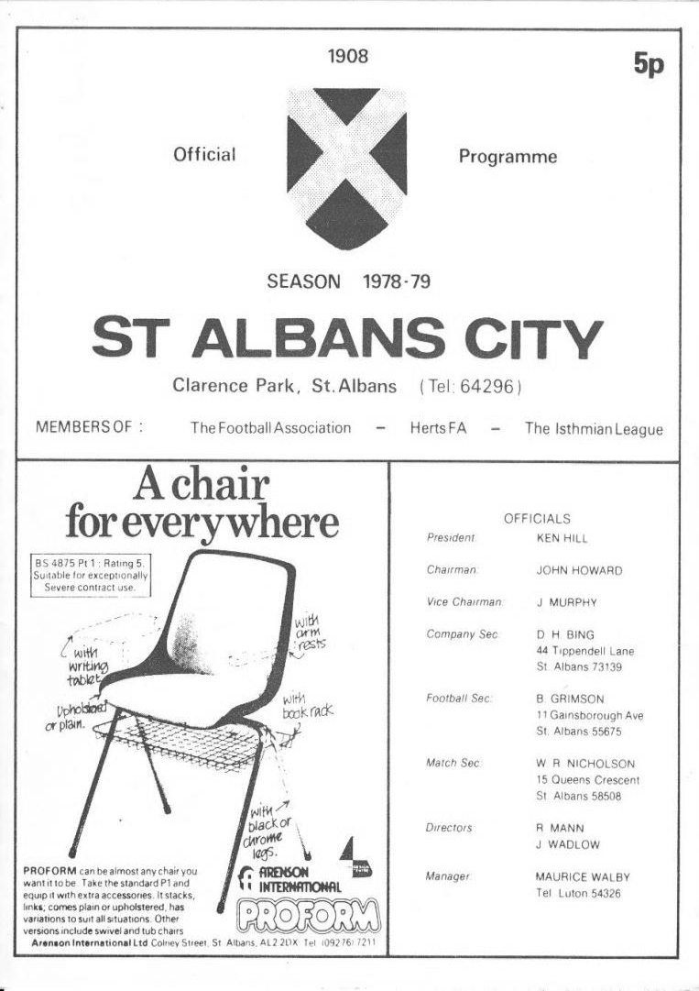
Our 2,000th match came with the Pat O’Connell revolution in full swing. After our Vase season we had earned further promotions in 1975/76, 1976/77 (by default) and again in 1977/78 as Isthmian League Division Two Champions. We had climbed four levels in four seasons and eventually we would have to find our level. This season we finished midtable in the Isthmian League Division One, but it was a measure of how far we had come that we could now visit places such as Clarence Park, the famous old home of St Albans City as equals and secure a draw. Both of goals that day came from Jeff Hunn.

Match 2,500: Camberley Town v Epsom & Ewell – 20th February 1988 – Won 3-1

Following two relegations in two seasons we found ourselves in the Isthmian League Division Two South, where Manager Ricky Kidd tried his best to get us straight back up. Unfortunately it wasn’t to be, but we were still substantially better than some of the clubs in this division, of which Camberley Town were one. We won comfortably by three goals to one this day with Kidd getting one of the goals and Steve Flack scoring the other two goals. Camberley’s goal was a very late consolation. In defence that day was Matt Elliott who would of course go on to have a very successful professional career. With exception of a two season break from 2002-2004 we have been meeting Camberley Town at least twice a season ever since then, which is largely why we have played them more than any other team (91 meetings).

Match 3,000: Hornchurch v Epsom & Ewell – 20th December 1997 – Drew 1-1

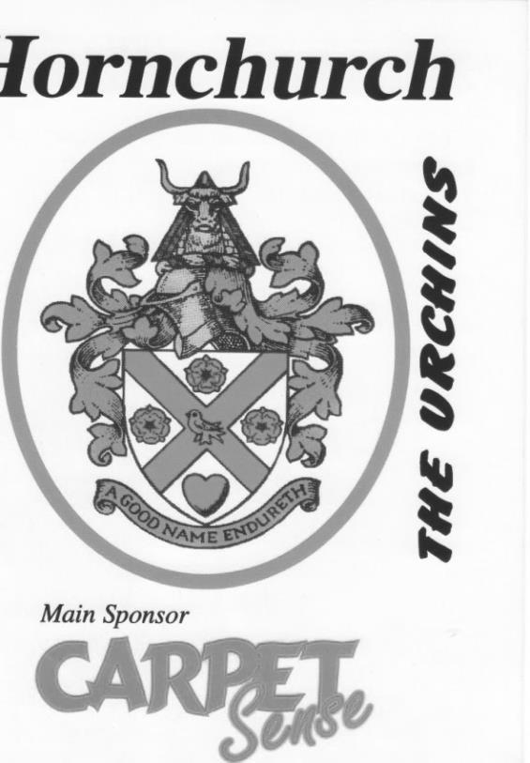
Bridge Avenue is much changed since our last visit there in 2002. Major improvements and investment have resulted in big F.A. Cup matches and a few seasons at a much higher level. When we used to visit, a running track surrounded the ground and the viewing experience was not the best.

We had a memorable experience there in August 1995 when Andy Boxall scored direct from the half way line from the kick off. Amazingly, he did that just 40 minutes before David Beckham scored from the same distance for Manchester United at Selhurst Park against Wimbledon! By the time we went there in December 1997 Boxall was still a regular scorer for us and we were on an incredible scoring run so impressive that I have no idea whether another club has ever achieved it. A late Andy Nimmo equaliser here was worth celebrating as it earned us a point, but the goal itself ensured that we had scored in an incredible 46 away League matches in a row; a run that had started back in August of 1995 and would reach 48 before Hemel Hempstead defeated us 1-0 in February of 1998.

Even if a club has managed to put that sort of run together, which I doubt, it is even more incredible when you realise that in those three seasons we would finish seventh twice and in 1996/97 actually ended up as low as 14th out of 17 clubs, scoring more goals that year than promoted Northwood!

Match 3,500: Horley Town v Epsom & Ewell – 15th December 2007 – Won 3-0

Although recent matches against Horley Town have been a little more even, historical matches have fallen hugely in our favour as they didn’t even beat us until 2011, our eighteenth meeting. This was our first ever visit to the New Defence and first trip to Horley since a Surrey Senior Cup tie in 1977 and we scored inside a minute through Darren Smith. He scored a second goal before the break but the most memorable moment came in the second half when Gary McLaughlin curled a beautiful free kick right into the top corner. We would finish tenth this season as we stabilised under Lyndon Buckwell’s first full season and better finishes would follow.

It is intriguing to note that our 1,000th, our 2,000th, our 3,000th and our 4,000th matches were all played away from home! Whilst it is hard to project roughly another twenty years ahead to what would be our 5,000th match, it would be nice to think that we could look back on these earlier matches while sitting comfortably at a new ground and wondering what it must have been like to be nomadic for so long.

Club Records - 28th October
Date | Day | Competition |  | Opponents |  | Scorers
28/10/33 | Sat | F.A. Cup 3q | A | Beddington Corner | 4-2 | A.Rance, L.Marlow, L.Graves, J.Jones
28/10/50 | Sat | Surrey Senior Cup 3q | H | Devas Institute | 3-2 | S.Faggetter, P.Jordan, F.Boatwright (pen)
28/10/61 | Sat | Amateur Cup 2q | H | Addlestone | 1-3 | B.Robinson
28/10/67 | Sat | Surrey Senior Cup 2q | H | Banstead Athletic | 1-2+ | o.g.
28/10/72 | Sat | Athenian League 2 | A | Edgware | 1-1 | B.Langton
28/10/78 | Sat | Isthmian League 1 | A | Maidenhead United | 0-1
28/10/80 | Tue | Isthmian League 1 | H | Kingstonian | 2-2 | A.Venturini (pen), T.Coombe
28/10/85 | Mon | Isthmian League  Premier Division | A | Dulwich Hamlet | 3-5 | R.Kidd (pen), T.Tuite, P.Kemp
28/10/89 | Sat | Isthmian League 2s | A | Eastbourne United | 0-1
28/10/95 | Sat | Isthmian League 3 | A | Tring Town | 1-1 | S.Smith
28/10/97 | Tue | Surrey Senior Cup  Preliminary Round | H | Egham Town | 1-3 | D.Arkwright
28/10/03 | Tue | Isthmian League Cup 1 | H | Waltham Forest | 0-1
28/10/06 | Sat | Combined Counties  Premier Division | H | Wembley | 2-3 | D.Marvell, A.Pero
28/10/08 | Tue | Combined Counties  Premier Division | A | Wembley | 5-0 | K.Hough (2), R.Burns (2), D.Marvell
28/10/14 | Tue | Combined Counties  Premier Division | H | Chertsey Town | 1-2 | K.Hough (pen)
Historical Decades
Date | Day | Competition |  | Opponents |  | Scorers
90 years ago – Epsom Town F.C.
29/10/27 | Sat | F.A. Cup 3q | A | Wimbledon | 2-3 | R.Marlow (2)
80 years ago – Epsom F.C.
30/10/37 | Sat | Amateur Cup 2q | H | Redhill | 1-4 | J.Jones
70 years ago – Epsom F.C.
01/11/47 | Sat | London League | A | Tilbury | 1-4 | B.Thursby
60 years ago – Epsom F.C.
26/10/57 | Sat | Amateur Cup 2q | A | Malden Town | 4-2 | J.Sorensen (2), J.Berry, J.Bangs
50 years ago – Epsom & Ewell F.C.
28/10/67 | Sat | Surrey Senior Cup 2q | H | Banstead Athletic | 1-2+ | o.g.
40 years ago – Epsom & Ewell F.C.
29/10/77 | Sat | F.A. Vase 1 | A | Ford United | 0-0
30 years ago – Epsom & Ewell F.C.
27/10/87 | Tue | Isthmian League 2s | H | Molesey | 2-0 | B.Perkins, o.g.
20 years ago – Epsom & Ewell F.C.
28/10/97 | Tue | Surrey Senior Cup  Preliminary Round | H | Egham Town | 1-3 | D.Arkwright
10 years ago – Epsom & Ewell F.C.
27/10/07 | Sat | Combined Counties  Premier Division | A | Dorking | 1-0 | K.Hough

History Corner – 28th October
90 years ago this week we visited Plough Lane, the famous old home of Wimbledon for an F.A. Cup Third Qualifying Round tie, where 7,631 spectators witnessed a cracking tie, which ended with the hosts victorious by the odd goal in five. Reg Marlow scored our goals but it wasn’t quite enough. (see report)
84 years ago today we hosted Beddington Corner in the F.A. Cup despite being drawn away from home. They conceded ground advantage for a bigger gate, but this obviously gave us a greater advantage and we took it, winning 4-2. It was somewhat of a surprise that after beating teams of the pedigree of Woking, Nunhead and Tooting & Mitcham that little Beddington Corner were next up, but this win put us into the final Qualifying round for the first time in our history and as we know, the journey didn’t end there!

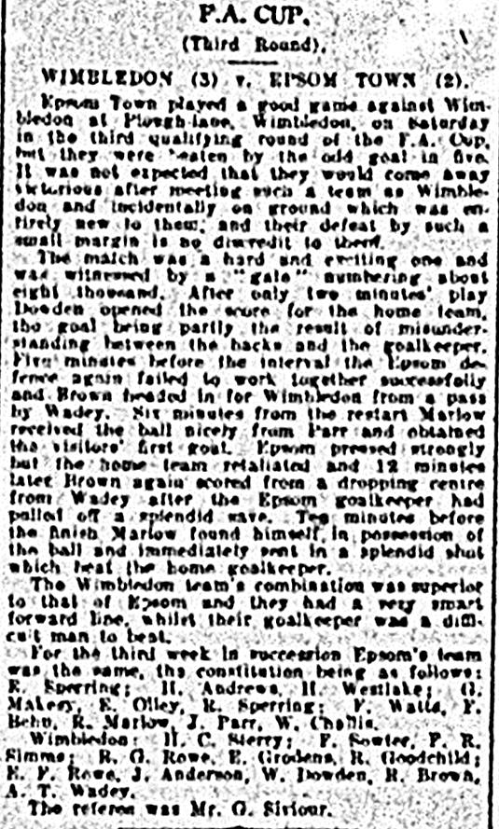
50 years ago today we hosted Banstead Athletic in the Surrey Senior Cup, expecting to progress against the Surrey Senior League outfit. In their ranks was Ernie Watkins, a player that had turned out for our club from 1945 to 1960 and who, to this day still sits in fourth place for our all-time appearances. He left in 1960 after our Manager Derek Evans felt that there was no use for him, but this was one of the greater Managerial mistakes in our history as Ernie went on to give great service to Banstead for eight further seasons, and he was imperious on this day as he played all 120 minutes of the match which Banstead won in extra time. Oh yes, I should point out that Ernie was by this time 46 years old! Who knows how many matches he’d have played if his career hadn’t been affected by the Second World War as he joined us straight afterwards in 1945 already aged 24 by then. His daughter Mary and her husband still live in Chase road, Epsom.

10 years ago this week we had one of the more memorable matches in our recent history as we travelled to Vale Farm, Wembley, knowing that a win would put us top of a League table for the first time in six years. Only one problem; we hadn’t won at Wembley since 1962!! It didn’t matter, as we scored in the first minute and raced to a four goal lead at half time.

As the snow came down in the second half we scored a fifth goal and with the area celebrating Divali (the Festival of Lights) there were fireworks going off in all directions too. Very picturesque and one of the most memorable matches in my time at the club!

EL Records Premier Challenge Cup
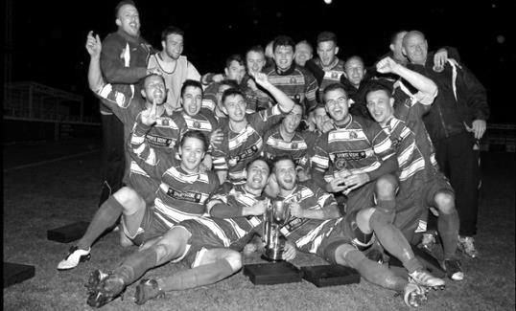
First Round
Camberley Town | 0-3 | Redhill
CB Hounslow United | 5-2 | Eversley & California
South Park Reserves | 3-4 | Horley Town
Staines Lammas | 2-2+ | Chertsey Town
Chertsey Town won 5-4 on penalties
Raynes Park Vale | 3-2 | Hanworth Villa
FC Deportivo Galicia | 1-0 | AC London
Sutton Common Rovers | 3-1 | Westfield
Worcester Park | 4-2 | Epsom & Ewell
Second Round
CB Hounslow United | 1-2+ | Worcester Park
Chertsey Town | 1-0 | Horley Town
Colliers Wood United | 4-1 | Balham
AFC Hayes | 0-1 | Cobham
Knaphill | 3-1 | Guildford City
Cove | 0-1 | Sutton Common Rovers
Bagshot | 1-4 | North Greenford United
Bedfont Sports | 6-1 | Farleigh Rovers
Redhill | 9-0 | Fleet Spurs
Kensington Borough | 4-3 | Raynes Park Vale
Bedfont & Feltham | 0-1 | Godalming Town
Chessington & Hook United | 5-2 | Sheerwater
Spelthorne Sports | 5-1 | Ash United
Walton & Hersham | 6-1 | Badshot Lea
Abbey Rangers | 1-3 | FC Deportivo Galicia
Banstead Athletic | 0-3 | Farnham Town
Third Round
Cobham | V | Farnham Town
North Greenford United | V | Colliers Wood United
Sutton Common Rovers | V | Redhill
Godalming Town | V | Chessington & Hook United
Knaphill | V | Kensington Borough
Bedfont Sports | V | Walton & Hersham
Spelthorne Sports | V | Chertsey Town
Worcester Park | V | FC Deportivo Galicia

Latest Results Grid
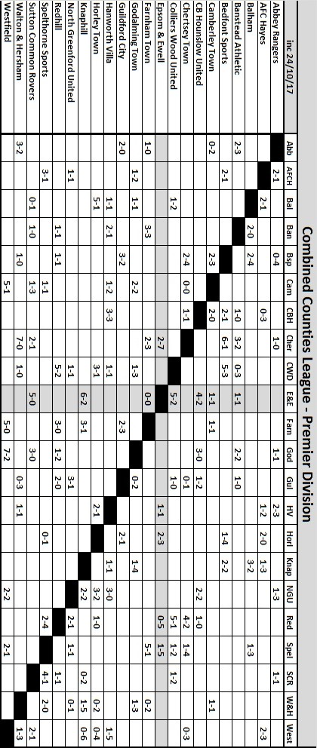

Centre page for results

Centre page for results

North Greenford United – Player Profiles
ASHLEY DAVY (Goalkeeper): An experienced keeper signed from Crockenhill in October 2017.

ALEX PARTRIDGE (Goalkeeper): A young keeper signed from Egham Town in September 2017.

MOHAMED KAMAL AKEL (Defender): Experienced player who was given International clearance after playing for AS Poissy in France and went on to make 11 First Team appearances last season.

GUY ANSAH-PALMER (Defender): Experienced defender who signed for NGU in July 2016 and went on to make 32 First Team appearances winning Players’ Player and Manager’s Player awards at the end of the season.

CHRIS GREENSLADE (Defender): A young defender signed from Diss Town in October 2017.

RYAN MURPHY (Defender): A very experienced full-back who has played with Danny Vincent and his father Colin Murphy in several teams, most recently New Hanford. He made 31 First Team appearances last season.

CARL BOWER (Defender/Midfielder): A talented young Luton Town Academy player who, after playing for NGU’s Under 18s and Reserves, went on to make 40 First Team appearances last season.

SEAN HILLIER (Defender/Midfielder): Experienced player who made over 300 appearances for NGU under five different managers before leaving at the end of the 2012-13 season. Played for Danny and Colin at New Hanford, but last season suffered a serious tendon injury. He re-joined the club in July 2017.

ALEX PEYTON (Defender/Midfielder): Young left-sided player who signed for NGU in July 2017.

SAMMY ADAMS (Midfielder): A talented young player who was a member of last season’s NGU Reserves.

SANDRO COSTA FERNANDES (Midfielder): Skilful and pacey wide player, signed from Hanwell, who made 26 First Team appearances in 2015-16, followed by an

impressive 48 appearances last season, scoring 8 goals.

STUART MULDREW (Midfielder): Experienced midfielder from Northern Ireland signed from Holbeach United in September 2017.

TOM O’REGAN (Midfielder): Experienced midfielder signed on loan from Hanwell Town in September 2017.

JAMES SIMMONDS (Midfielder): A talented and experienced midfielder who played for Danny and Colin at New Hanford before signing for Hanwell. Joined NGU in December 2016 and made 10 First Team appearances.

DANIEL VINCENT (Midfielder): An experienced ex-NGU midfielder who first joined the club in 2012 making 58 appearances over two seasons. He played for New Hanford before re-joining NGU at the beginning of last season, making an impressive 52 appearances and scoring 14 goals.

CHARLIE CONNOR (Midfielder/Forward): Talented and versatile player who joined NGU from Chalfont St Peter in 2015-16 making 19 appearances. Last season he made a further 41 First Team appearances scoring 10 goals

NATHANIEL MENSAH (Midfielder/Forward): Attacking wide midfielder or centre forward transferred from AFC Hayes in September 2017.

JAMAL VELINOR (Midfielder/Forward): Strong, versatile player signed in July 2016 after playing for Bedfont and Feltham. Last season he went on to make 42 First Team appearances, scoring 10 goals.

JORDAN ELLIS (Striker): Young, pacey striker who joined NGU in July 2017 and scored his first goal for the club in the friendly against local rivals Hanwell Town.

DANIEL MAKOWSKI (Striker): A young striker signed from Hampton & Richmond Borough in September 2017.

BRIAN TESTOLIN (Striker): A young striker signed on loan from Harrow Borough in October 2017.The club was founded in September 1944 as a youth team.

North Greenford United – History
The club was founded in September 1944 as a youth team.

The following season saw the formation of a senior side and the club entered the Harrow League in 1947 and later the Middlesex County League. In May 1983 promotion was gained to the Spartan League with the club joining the Premier Division in 1988, but then resigning in 1994 to rejoin the Middlesex League. Keen to regain Senior Status, ground improvements were undertaken, including the installation of floodlights at Berkeley Fields, and in 2002 the club was elected to the Combined Counties Premier League.

In 2003/04 the club, managed by Steve Hawkins, were runners up in the Premier Challenge Cup losing 4-1 to AFC Wimbledon in front of a crowd of over 5,000 at Woking FC. In season 2004/05 the club finished runners up and in the following year finished 13th as well as reaching the semi-final of the League Cup. The following season 2006/07 saw the team, under Mick Harvey, go one round better, unfortunately losing 4-1 to Merstham in the final.

Steve Ringrose took over the Manager’s job at the beginning of season 2008/09. In his first season Steve led the team to second place in the Premier League with the club finishing Runners-up to Bedfont Green. Season 2009/10 proved the most successful in the club’s history when the First Team became Combined Counties Champions, earning promotion to the newly-formed Southern Football League Division One Central, as well as winning the MFA Charity Cup beating Enfield Town 1-0 at Hampton & Richmond’s ground in front of a large crowd.

Despite having a difficult first season at the higher level the First Team succeeded in retaining its Step 4 status. However, despite notable cup successes, the first half of season 2011/12 saw the club struggling in the league. Steve Ringrose was replaced by Neil Shipperley in December 2012 and Shipps managed to successfully steer the side away from the threat of relegation.

Experiencing an even more difficult time at the start of season 2012/13, Neil Shipperley was re-appointed for a second term replacing Jon-Barrie Bates as First Team Manager at the beginning of October. However, the team continued to struggle and, having lost 14 league matches on the trot, our only consolation was that Woodford United had still failed to notch up a single point. Our campaign that year was saved by an amazing end-of-season run which saw the team finish above the relegation places in 19th place.

We were hoping to continue where we left off at the start of the following season’s campaign but, again after excellent cup runs, we struggled in the league and narrowly escaped the drop after crucial wins against our two fellow relegation contenders, Chertsey and Ashford Town (Middx). Reserve Team Manager Paul Palmer, supported by Don Bennett, replaced Neil Shipperley following Neil’s resignation midway through the season.

Following an indifferent start to the 2014/15 campaign it was decided to part company with Paul and ask Don to take over. Results though did not improve and in December 2014 Don tendered his resignation. Reserve Manager Barry Morris took over in a caretaking capacity assisted by coaches George Bouhet and Fitzroy McLeod.

After an initial struggle another impressive end-of-season run saw the team finish four points clear of bottom club AFC Hayes, and we were granted a reprieve by the FA. Barry and his team were re-appointed on a permanent basis for the forthcoming campaign, but in September 2015 Barry resigned due to work commitments, and George accepted the position of Acting First Team Manager.

Once again, unfortunately, poor results left the club firmly rooted at the bottom of the Central Division, and in November 2015 the committee appointed two ex-Greenford players – Ricky Pither

and Danny Bennell – as joint First Team managers to replace George. Despite some promising performances, results still did not improve significantly. In the end four wins and six draws were not enough to secure the points needed to avoid the drop. On this occasion, a strong end-of-season run could not be achieved and the team ended their campaign well adrift at the foot of the table. There was to be no chance of being granted another reprieve.

When relegation was confirmed we expected to be moved to either the Spartan South Midlands or Combined Counties League. It therefore came as a shock when the FA announced its decision to place the club in the Hellenic League. Given the serious implications of such a move, both in terms of travel costs and player recruitment, the Committee decided to mount a formal appeal. Eventually the appeal was upheld and we were offered a place in the Combined Counties Premier Division, even though for one season the league would have to run with 23 clubs.

Given their wide knowledge of local clubs and players, Ricky and Danny’s team were invited to continue in their roles with Mark Chandler taking over as joint manager following Danny’s resignation. Unfortunately, due to poor league results which left the club languishing at the foot of the CCL Premier Division table, the NGU committee reluctantly decided to part company with Ricky and Mark at the beginning of October 2016.

The experienced management team of Danny Vincent and Colin Murphy were offered and accepted the position, and were duly appointed in time to take charge of the Chertsey Town home game on 11th October. The club eventually finished the 2016/17 season in a creditable 13th position on 58 points, and with Danny and Colin still in charge, assisted by Terry Schofield who has joined the First XI management team, we are looking for a higher finish this term.

From behind the goal
Camberley Town 1-1 Epsom & Ewell
Combined Counties League - Premier Division - Saturday 14th October 2017

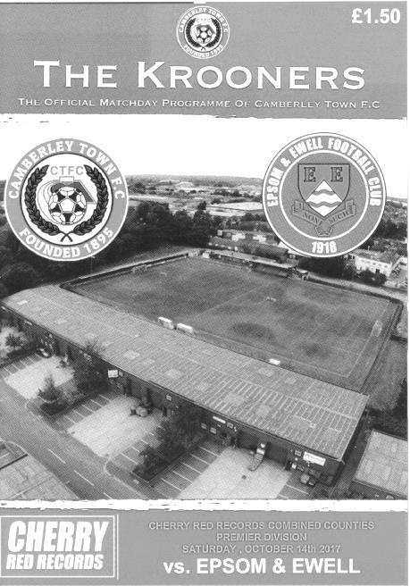
Hard earned point for beleaguered Salts

Krooner Park has not been a very happy hunting ground in recent years but a very welcome point was picked up from a hard working performance in our club record 91st meeting with Camberley Town.

The performance itself was much improved from recent weeks as we had to deal with a bit of adversity too. Only 12 players made the journey to Camberley and we lost Scott Murphy to a groin injury early in the game, but reshuffled and managed to deal with the loss. We then recovered from the setback of conceding in the second half by equalising soon afterwards and by the end of the match the home team had run out of ideas.

We were missing a number of players again today and having released a few others over the last week Lloyd Connolly made his debut for the club after joining from Westfield. He slotted in on the right wing and did well, also becoming the first player to score on his debut since Jordan Gallagher.

The game started with our boys going down the hill and we faced a few corners in the opening minutes, one of which was headed out of the danger area by Dan Rose but we had our first opportunity after 13 minutes when Kyle Hough made some space inside the penalty area and his shot was spilled by Kallum Lunn but there was no one there to knock in the loose ball. Three minutes later Jamie Hatfield struck a swerving shot at goal from 20 yards which was parried away. Conor Young was next in action as he cut out a right wing delivery but Ben Dyson then put in a good cross from the right which was met by a looping Rob Hendry header although Lunn was able to make the comfortable catch on his goal line.

Unfortunately in the 35th minute Murphy went down and had to be replaced by Liam Roberts. Whilst our new man added value to our attack it came at the expense of Dale Marvell who found himself doing Murphy's role alongside Alex McKay. It also left us with no substitutes remaining.

Probably the best chance of the match then fell our way just before half time when a clever touch pass put Hough through on goal but as he approached Lunn the ball got away from him and the keeper got a toe to the ball which rebounded off our man and out for a goal kick.

The second half was always going to be difficult and the home team poured forward, one strike flew off our crossbar from 30 yards out. The hosts were trying shots from all areas and it bore fruit when in the 55th minute another speculative effort was deflected straight into the path of Jamie Hoppitt who buried the ball past Young from close range. This was a real blow but fortunately we were able to fight straight back and in the 57th minute Hough received the ball on the edge of the area and he rolled the ball back for Hatfield to deliver a peach of a cross from the left touchline where Connolly headed the ball back across Lunn and into the net from eight yards out.

We had a scare a few minutes later when a Camberley free kick was delivered to the far post and headed goalwards from close range but luckily the ball went straight at the grateful Young who made the save. The home side kept pushing for a winner and Dyson and then McKay made timely challenges inside our own six yard box to relieve the pressure before Young made a fine save from a free kick awarded on the edge of the area and the five minutes injury time felt like ten before the final whistle blew.

This was our fourth draw of the season and showed a marked improvement on our showing at Knaphill. Although Camberley had more possession, we defended well and deserved a point for that alone. However, we remain at the foot of the table where the really bad news came from elsewhere as results in other matches increased the gap between us and safety from six points to eight. However, there were signs that the players who we currently have at the club are now committed to the cause. All we need are a few more!

Epsom and Ewell: Conor Young, Ben Dyson, Jamie Hatfield (c),
Scott Murphy, Alex McKay, Dan Rose. Rob Hendry, Ashley Thompson,
Kyle Hough, Dale Marvell, Lloyd Connolly

Sub: Liam Roberts for Murphy (35)

From behind the goal
Rusthall 2-7 Epsom & Ewell
Buildbase F.A. Vase - First Round - Saturday 21st October 2017

Thompson double and Griffin stunner seal Salts Vase passage

It's been a long time coming, but finally at the Jockey Farm Stadium, seventy-six days after the season started we finally won our first match of the season. However, surely no one could have possibly expected this score line as we took full advantage of a home sending off to run away with this F.A. Vase tie in the end by the amazing margin of seven goals to two!

Much has been written about our season so far, but Rusthall, recently promoted into Step Five had been struggling in recent matches themselves, having not won since their previous Vase match against Crawley Down Gatwick in September. As a result it would have been almost impossible to work out how this match might end up, and that's before you throw in forty mile an hour winds and the unpredictability of the F.A. Vase itself; a competition where we have been mostly poor in the last twenty five years, with exception of a Fourth Round trip in 2010.

Whilst no one expects a run of that sort this year, it was important to finally get off the mark as the winless run had begun to get rather frustrating for players, supporters and Management alike. At a Committee Meeting earlier this week a full vote of confidence was given to our Manager who will be given the whole of the season to recover our position and although I don't know whether the players were aware of this decision, they certainly played with more freedom. In fact, on a perfect playing surface our boys passed the ball around confidently as we opened the match strongly.

It helped that there were only two changes this week with Adam Heagney returning to the line up and making his 50th appearance in place of Ben Dyson, whilst Reisse Griffin was available and he slotted in for Scott Murphy, who had been unable to shake off the injury incurred at Camberley seven days previously. Another milestone was reached today by Rob Hendry who made his 100th appearance and whilst he didn't score, he recorded four assists in the match as memories flooded back to the halcyon days of the last few seasons when we used to score goals for fun.

The first action of the match came from the home team as Conor Young tipped away a twenty-five yard effort at full stretch for a corner. However, at the other end, Joe Cullip had a concern of his own to deal with as an errant back pass slipped under his weaker left foot and out for a corner. Hendry's delivery let him down on that occasion, but he made amends in the 14th minute when a delicious delivery from another corner was glanced in by Ashley Thompson. You could say it was the perfect start but it actually got better just two minutes later when a ball in was misjudged by a defender and fell straight to Thompson just eight yards out. If he had made a full contact of the ball it would have surely flown over the bar, but he shinned it a little and it looped a little fortuitously over Cullip and dropped just under the bar to give us our first two goal lead of the season.

It nearly became three-nil in the 20th minute as Jamie Hatfield's dangerous low ball across the six yard box slipped under Cullip, but in doing so, he took the pace off it a little and Lloyd Connolly, coming in at the far post found the ball just behind him as a result and was only able to knock the ball wide as he attempted to "Rabona" the ball in.

We continued to control the game for half an hour but the home team started to push us back a little from that point. A strike just cleared our bar and then we had to execute a panic clearance but then conceded in the 36th minute when we gave away a free kick for handball on the edge of the area which wasn't cleared and Stephen Harper drilled the loose ball past Young from about 12 yards.

We responded well and a foul on Hendry gave Heagney the chance to strike the free kick at goal from 25 yards where Cullip was forced into a fine save. However, the defining moment of the match came in the 41st minute when Paul Butler slid into a challenge on Kyle Hough, leaving him in a heap and a nasty cut on the leg. Even then it was a surprise to see the referee show him the red card. Despite this, the home side continued their attacks and although Kyle Hough got a twenty yarder on target just before the whistle, we clung precariously to a one goal lead as the players walked off.

Clearly efforts were made to keep a closer eye on the impressive Harper who was not a factor in the second half and then we had one of those "I was there" moments in the 48th minute as Griffin came out of defence with the ball, but with the home defence expecting him to lay the ball off at some point he ran straight through them, covering over seventy yards before slotting the ball past Cullip from just inside the box! I am not expecting to see a goal of that quality again this season and it was the best scored for us since Matt Ferdinando's incredible overhead kick against Farnham Town in September 2015. It was superb and three minutes later Dan Rose got across his man to reach a right wing delivery and squeeze the ball in off the near post to extend the lead to 4-1 and register his first goal for the club.

Thompson nearly scored his third with a powerful strike just beyond the far post before Hough cut in from the right and tried to squeeze the ball in at the near post but Cullip denied him. Connolly was next to get down the right flank but his cut back lacked power and Cullip was able to retrieve the ball before it reached our strikers.

We had one final concern in the 73rd minute when Young called for Griffin to head the ball back, but the header was a poor one which forced Alex McKay into an awkward position and he was adjudged to have brought his man down when through on goal. People nearer the incident said that the challenge occurred outside the penalty area but had it been so, he may well have picked up a red card instead of the yellow as the new rules make it clear that an attempt to play the ball is sufficient to avoid a sending off when the ball is there. There was further drama as Young then saved Harper's penalty, only to see the Assistant flag to say he was off his line in making the save. This seemed harsh on our man but Harper then stuck the penalty in exactly the same place he had put the previous one in the 74th minute to reduce the arrears.

But our players didn't appear particularly concerned by this and five minutes later it was McKay who restored our three goal lead as he battled his way through to head another Hendry corner in from close range. We then followed this up with two late goals as substitutes Cristian Castell and Jason Nwachukwu combined for the latter to thump the ball left footed into the corner from eight yards after 87 minutes and three minutes into injury time Nwachukwu scored his second of the match as he reacted quickest to a Hendry long range free kick that Cullip turned onto the bar and he drilled the loose ball into the bottom corner.

This was the first time in seventeen years that we had beaten a Step Five Kent based team (VCD Athletic - 2000) and if someone had told me that after our start to the season we would score seven times and also that Hough wouldn't get any of them, I'd have said they needed to lie down in a darkened room as they were hallucinating! Now for the first time this season we can celebrate a win and some prize money and enjoy the anticipation of awaiting the Second Round draw on Monday afternoon.

Epsom and Ewell: Conor Young, Adam Heagney, Jamie Hatfield (c), Reisse Griffin,
Alex McKay, Dan Rose. Rob Hendry, Ashley Thompson, Kyle Hough, Dale Marvell, Lloyd Connolly

Sub: Jason Nwachukwu for Connolly (75), Cristian Castell for Marvell (84),
Ben Dyson for Rose (90)

Every Opponent A-Z
Over the years we have played many, many different opponents. Exactly how many is a difficult question, as it all depends on your definition. Are Camberley & Yorktown different to Camberley Town, or are Epsom Town different to Epsom F.C. or Epsom & Ewell F.C.?

In my analysis I have classed both of the above examples as the same team, and will work through them all from A to Z. Some we have played many times, whilst others we have met just once or twice. Enjoy!

West Wickham: Played 1 - W1 D0 L0 - F3 A1 - PPG - 3.00 - Perfect

West Wickham were a club that briefly surfaced in the sixties and were based in the Addiscombe area. We drew them away from home in the Amateur Cup on 24th October 1964 but the match was switched to West Street where we cruised into a three goal half time lead with two goals from Bill MacKay and another from Don Bruce. The final score finished 3-1 and we never met again!

Westfield: Played 21 - W12 D3 L6 - F43 A36 - PPG - 1.86 - Good

Just two weeks before the West Wickham match, we had met Westfield for the first time, also in the Amateur Cup, winning 1-0, again thanks to Bill MacKay. The club had joined the Surrey Senior League in 1963 and would be one of its better teams before reaching a high water mark in the early seventies; a mark they are threatening to exceed this season.

The club were based, now as then in Woking Park, but at a much more basic venue with just a wooden building housing all the facilities. Those who are familiar with the new ground at Westfield may like to know that the old clubhouse would have been situated more or less beyond the far side hill as you look out from the clubhouse.

Westfield had to wait just three weeks for their revenge for that Amateur Cup defeat, as we were back at Woking Park for a Surrey Senior Cup tie, crashing 5-1. This wasn’t such a shock really though, as we were about to suffer our first relegation in history to the new Athenian League Division Two which might technically have been above the Surrey Senior League still, but in reality there was very little in it!

Our next meeting came fifty years and one week ago today when we were again paired in the Amateur Cup, this time at West Street, where we ran away with it, scoring four times in the second half to register a 6-1 victory. Roy Battams and Ted Stafford scored twice each with the other goals coming from reliable defender John McNaught and member of the Wall of Fame for 200 appearances, Graham Hemphrey.

Our next batch of meetings were real title battles. In 1973 we had been cast adrift by the Athenian League and were accepted into the Surrey Senior League, where the reigning Cup and League holders were Westfield, under the Management of John Martin, a future Assistant Manager of our club. In 1973/74 they would retain the League title, while under the new Management of Pat O’Connell we would finish in second place, but in four meetings between the teams, they never beat us as two were won and two were drawn.

The first of these on 17th November 1973 was won by our boys 2-1 with goals from Dave Ritman and Kelvin Gregory. “Where was the little fella” I hear you say. Well, Tommy Tuite did play in that match, and would make his presence felt in the other three matches, scoring in all of them. The next meetings were in the League Charity Cup; an event that we had won back in the seventies but was arguably a secondary competition to the League Cup that had started up in the fifties.

We drew there 2-2 before winning the replay 2-1 and on 14th May 1974, by which time the League

had already been decided, we drew there again by the score of 1-1.

For Westfield however, an unfortunate change was coming. There was a new Manager at Wimbledon, who recruited the legendary Allen Batsford from Walton & Hersham. His team had won the Amateur Cup at Wembley without conceding a goal in 1973 and were one of the biggest teams in Surrey at the time, winning 4-0 in 1973/74 at Brian Clough’s Brighton & Hove Albion team in an F.A. Cup replay. Clearly Wimbledon were impressed and Batsford would bring many of his players with him to Plough Lane, including a young Dave Bassett, where they would have major success in the 1974/75 F.A. Cup, defeating First Division Burnley on their own ground and holding Leeds United to a replay. Promotion to the Football League came in 1977, mostly as a result of these achievements.

However, Walton & Hersham needed a Manager and Martin fitted the bill after doing so well at Westfield. Admittedly this story did not end well with Martin failing to last the season and the Swans being relegated to the lower Division of the Isthmian League. It was equally disastrous for Westfield who finished bottom of the Surrey Senior League, just twelve months after lifting the title. We beat them three times, 3-1 and 4-1 in the League and 6-2 in the Charity Cup but of course we were a bit warm ourselves that year and won the title easily, so the results were no surprise.

It wouldn’t be until 1980/81 that Westfield would return to the top three and by a strange quirk of fate, that is when we next met. We were a very good side that year, coming third behind two giants of the game in three time Vase winners Billericay Town and that season’s F.A. Trophy winners Bishops Stortford. Neither team beat us in the four matches we played as they all finished in draws, but we did have a little bonus that year as we lifted the Surrey Senior Cup. It nearly didn’t happen though as we required an own goal to progress 2-1 back in the opening round at Woking Park on 13th December 1980 with a full side out, excepting the keeper.

Twenty-two years passed before we met again in the same competition, but just 16 spectators, our lowest ever home attendance, witnessed our 4-2 win at Merland Rise, despite being in the Division One South at the time and sitting near the top of the table!

Since then we have had nine meetings, eight of which came in the League and one, last May in the League Cup Final where we were defeated 4-1 at Windsor. They were demoted back in 2006 when we and other clubs were transferred into the Combined Counties League and did not get promotion until 2013 by which time the ground had been redeveloped. It is a very impressive sight on one side of the ground and the facilities are now good enough to guarantee the promotion that looks very likely this coming May. Below is a rare picture of how Westfield used to look!

Player Sponsorship
Here is the new list for the season, with new photos where available for the 2016/17 season showing all of our players and Management that are available for sponsorship.

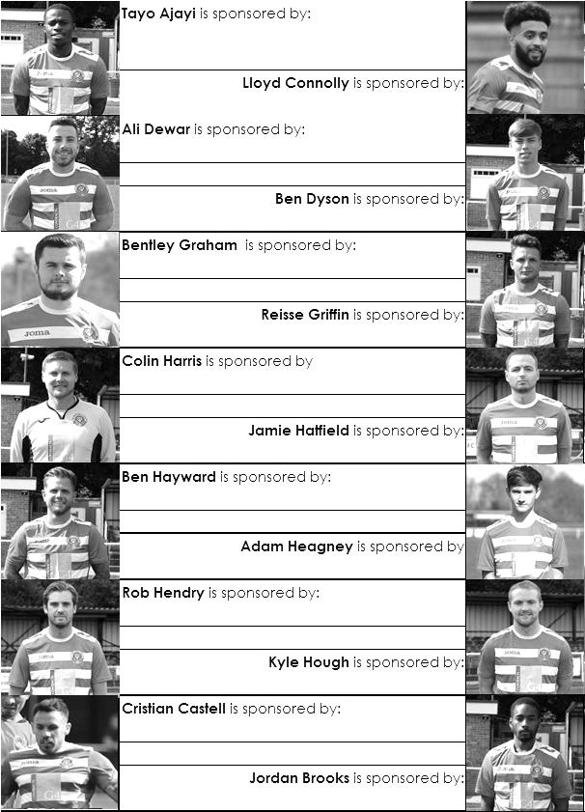

Sponsorship costs just £40 and it is easy to do. Just select a player who has not been previously sponsored and let a Committee Member know that you would like to sponsor them. Beware though. Until we have received the money it is possible for someone to jump in front of you, so don’t delay, sponsor today!

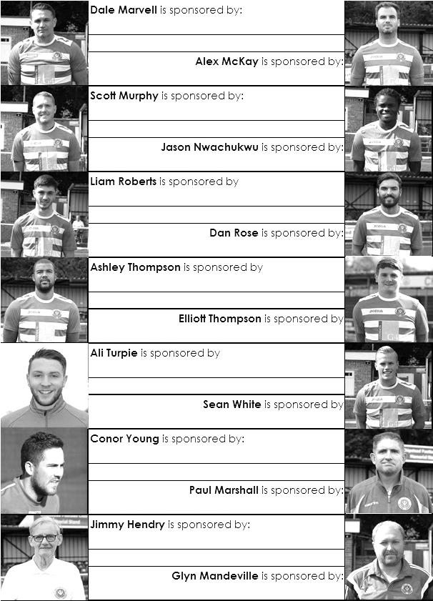

F.A. Vase
Second Round – 11th November
Stockton Town | V | Bootle
North Shields | V | Knaresborough Town
Dunston UTS | V | Worksop Town
AFC Darwen / Marske United | V | Shildon
Sunderland Ryhope CW | V | City of Liverpool
1874 Northwich | V | Tow Law Town
Hall Road Rangers | V | Pontefract Collieries
West Auckland Town | V | Billingham Town
Team Northumbria / Runcorn Linnets | V | Sunderland RCA
Ashton Athletic / Liversedge | V | Morpeth Town
Bedlington Terriers | V | Newcastle Benfield
Thornaby | V | Whitley Bay
Wolv SC / Staveley MW | V | Rugby Town
Hinckley AFC | V | AFC Mansfield
Coleshill Town | V | Blaby & Whetstone Athletic
Godmanchester Rovers | V | Deeping Rangers
Brocton | V | Shepshed Dynamo
Desborough Town | V | Pinxton
Quorn | V | Coventry United
Racing Club Warwick | V | Alsager Town
AFC Wulfrunians / Thurnby Nirvana | V | Eastwood Community
Walsall Wood | V | Holbeach United
Worcester City | V | Highgate United
Kimberley MW | V | Stourport Swifts
Sporting Khalsa | V | Bromsgrove Sporting
Tring Athletic | V | Ely City
Welwyn Garden City | V | Newport Pagnell Town
Thetford T / Debenham LC | V | Wisbech Town
Biggleswade | V | Crawley Green
Yaxley | V | Peterborough Northern Star
Leighton Town | V | London Lions
Hullbridge Sports / Colney Heath | V | Wembley
Sun Sports | V | London Colney / Cogenhoe United
Tower Hamlets | V | Enfield 1893
Enfield Borough | V | Berkhamsted
Gorleston | V | Framlingham Town
Wisbech St Mary | V | Norwich CBS
Great Wakering Rovers | V | FC Romania
Erith Town | V | Windsor
Walton & Hersham | V | Hanworth Villa
Haywards Heath Town | V | Sevenoaks Town
Whitstable Town | V | Epsom & Ewell
Meridian VP | V | Erith & Belvedere / Horley Town
Sheppey United | V | Beckenham Town
Westfield | V | Canterbury City
Thatcham Town | V | Broadbridge Heath
Southall | V | Lordswood
Crowborough Athletic | V | Croydon
Bracknell Town | V | Cray Valley (PM)
Corinthian | V | Eastbourne Town
Chichester City | V | Deal Town
Christchurch | V | Fareham Town
Team Solent | V | Tavistock AFC
Exmouth Town | V | Blackfield & Langley
Sholing | V | Wellington AFC
Wantage Town | V | Melksham Town
Newport (IW) | V | Hengrove Athletic
Baffins Milton Rovers | V | Cullompton Rangers
Buckland Athletic | V | Bradford Town
Hamble Club | V | Brockenhurst
Willand Rovers | V | Westfields
Farnham Town | V | Bridgwater Town
Plymouth Parkway | V | Bodmin Town / Swanage Town & H
Portland United / Horndean | V | Royal Wootton Bassett Town

Surrey Senior Cup
First Round
Westfield | 3-2 | Abbey Rangers
Dorking Wanderers | 4-1 | Walton Casuals
Knaphill | 1-2 | Met Police
Second Round
Westfield | V | Camberley Town
Woking | V | Chipstead
Chertsey Town | V | Spelthorne Sports
Dorking Wanderers | V | Godalming Town
Horley Town | V | Kingstonian
AFC Croydon Athletic | V | Met Police
Carshalton Athletic | V | Egham Town
Croydon | V | Molesey
Farnham Town | V | Whyteleafe
Sutton United | V | Redhill
Banstead Athletic | V | Leatherhead
Sutton Common Rovers | V | Epsom & Ewell
Guildford City | 2-2 - 3-5p | Colliers Wood United
Merstham | V | Walton & Hersham
South Park | V | Ashford Town (Mx)
Tooting & Mitcham United | V | Corinthian Casuals

Scouting the Opponent – Whitstable Town
The FA have decreed that we will visit the Belmont, home of Whitstable Town since 1886 in the Second Round of the F.A. Vase on Saturday 11th November.

Until recently they were an Isthmian League team but were relegated in 2016 and have settled in the Southern Counties East League, where they currently sit in midtable, higher than Rusthall, but with games in hand.

For those wondering, yes, we have been there before, on 25th September 1954 when we secured a 0-0 draw in the F.A. Cup. However, four days later we lost a Wednesday home replay 4-1, but it must be remembered that the Kent League was a professional one back then, so it was no disgrace.

When I visited in 2007, the ground was a classic, with an old wooden stand and much to remind you of how it probably looked back in the fifties. I believe that is still the case!
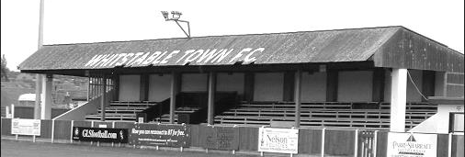

Southern Counties League East
incl Saturday 21st October | P | W | D | L | F | A | Pts | GD
Sevenoaks Town | 10 | 8 | 1 | 1 | 22 | 7 | 25 | +15
Croydon | 14 | 8 | 1 | 5 | 24 | 18 | 25 | +6
Crowborough Athletic | 11 | 7 | 3 | 1 | 28 | 14 | 24 | +14
Sheppey United | 11 | 7 | 2 | 2 | 29 | 12 | 23 | +17
Corinthian | 12 | 7 | 2 | 3 | 21 | 12 | 23 | +9
Lordswood | 11 | 6 | 4 | 1 | 21 | 14 | 22 | +7
Bearsted | 13 | 7 | 1 | 5 | 19 | 15 | 22 | +4
AFC Croydon Athletic | 12 | 6 | 2 | 4 | 17 | 17 | 20 | 0
Whitstable Town | 8 | 5 | 0 | 3 | 12 | 8 | 15 | +4
Beckenham Town | 10 | 5 | 0 | 5 | 21 | 18 | 15 | +3
Canterbury City | 11 | 4 | 2 | 5 | 19 | 17 | 14 | +2
Deal Town | 10 | 4 | 2 | 4 | 11 | 12 | 14 | -1
Cray Valley (PM) | 12 | 4 | 0 | 8 | 20 | 26 | 12 | -6
Glebe | 10 | 3 | 2 | 5 | 11 | 19 | 11 | -8
Rusthall | 10 | 2 | 3 | 5 | 11 | 22 | 9 | -11
Chatham Town | 11 | 2 | 3 | 6 | 8 | 21 | 9 | -13
Tunbridge Wells | 9 | 2 | 2 | 5 | 12 | 24 | 8 | -12
Erith Town | 8 | 2 | 0 | 6 | 8 | 13 | 6 | -5
Rochester United | 11 | 1 | 2 | 8 | 10 | 23 | 5 | -13
Hollands & Blair | 10 | 0 | 2 | 8 | 10 | 22 | 2 | -12

Combined Counties League Premier Division
Opponents All-time Records
inc Saturday 21st Oct | P | W | D | L | F | A | PPG | GD | Best  Win | Worst  Loss
Godalming Town | 1 | 1 | 0 | 0 | 2 | 1 | 3.00 | +1 | 2-1 | X
Abbey Rangers | 4 | 3 | 0 | 1 | 11 | 4 | 2.25 | +7 | 7-1 | 2-3
Sutton Common Rovers | 13 | 9 | 2 | 2 | 30 | 19 | 2.23 | +11 | 4-0 | 0-5
Horley Town | 31 | 21 | 5 | 5 | 69 | 34 | 2.19 | +35 | 6-0 | 1-3
Spelthorne Sports* | 8 | 5 | 2 | 1 | 16 | 11 | 2.13 | +5 | 6-2 | 1-5
Bedfont Sports | 11 | 7 | 2 | 2 | 21 | 12 | 2.09 | +9 | 5-1 | 0-4
Banstead Athletic | 38 | 23 | 7 | 8 | 62 | 38 | 2.00 | +24 | 5-0 | 0-4
Guildford City | 18 | 11 | 1 | 6 | 35 | 22 | 1.89 | +13 | 5-1 | 1-5
Westfield | 21 | 12 | 3 | 6 | 43 | 36 | 1.86 | +7 | 6-1 | 0-4
Colliers Wood United | 24 | 14 | 2 | 8 | 47 | 39 | 1.83 | +8 | 4-0 | 0-5
Knaphill | 9 | 5 | 1 | 3 | 19 | 15 | 1.78 | +4 | 4-0 | 2-6
Farnham Town | 16 | 8 | 4 | 4 | 27 | 25 | 1.75 | +2 | 3-1 | 1-4
Walton & Hersham | 52 | 25 | 11 | 16 | 105 | 99 | 1.65 | +6 | 8-0 | 1-9
Hanworth Villa | 18 | 8 | 5 | 5 | 39 | 28 | 1.61 | +11 | 5-0 | 1-4
Camberley Town* | 91 | 38 | 23 | 29 | 159 | 126 | 1.52 | +33 | 9-1 | 0-4
Redhill | 34 | 14 | 2 | 18 | 63 | 74 | 1.29 | -11 | 7-2 | 2-8
Chertsey Town | 50 | 19 | 5 | 26 | 77 | 94 | 1.24 | -17 | 3-0 | 0-7
North Greenford United | 12 | 4 | 2 | 6 | 18 | 22 | 1.16 | -4 | 3-0 | 1-4
AFC Hayes | 10 | 2 | 3 | 5 | 18 | 18 | 0.90 | 0 | 7-0 | 0-3
CB Hounslow United | 4 | 1 | 0 | 3 | 6 | 11 | 0.75 | -5 | 2-0 | 1-5
Balham | - | - | - | - | - | - | - | - | - | -
* includes one abandoned match v Camberley and one loss on penalties v Spelthorne

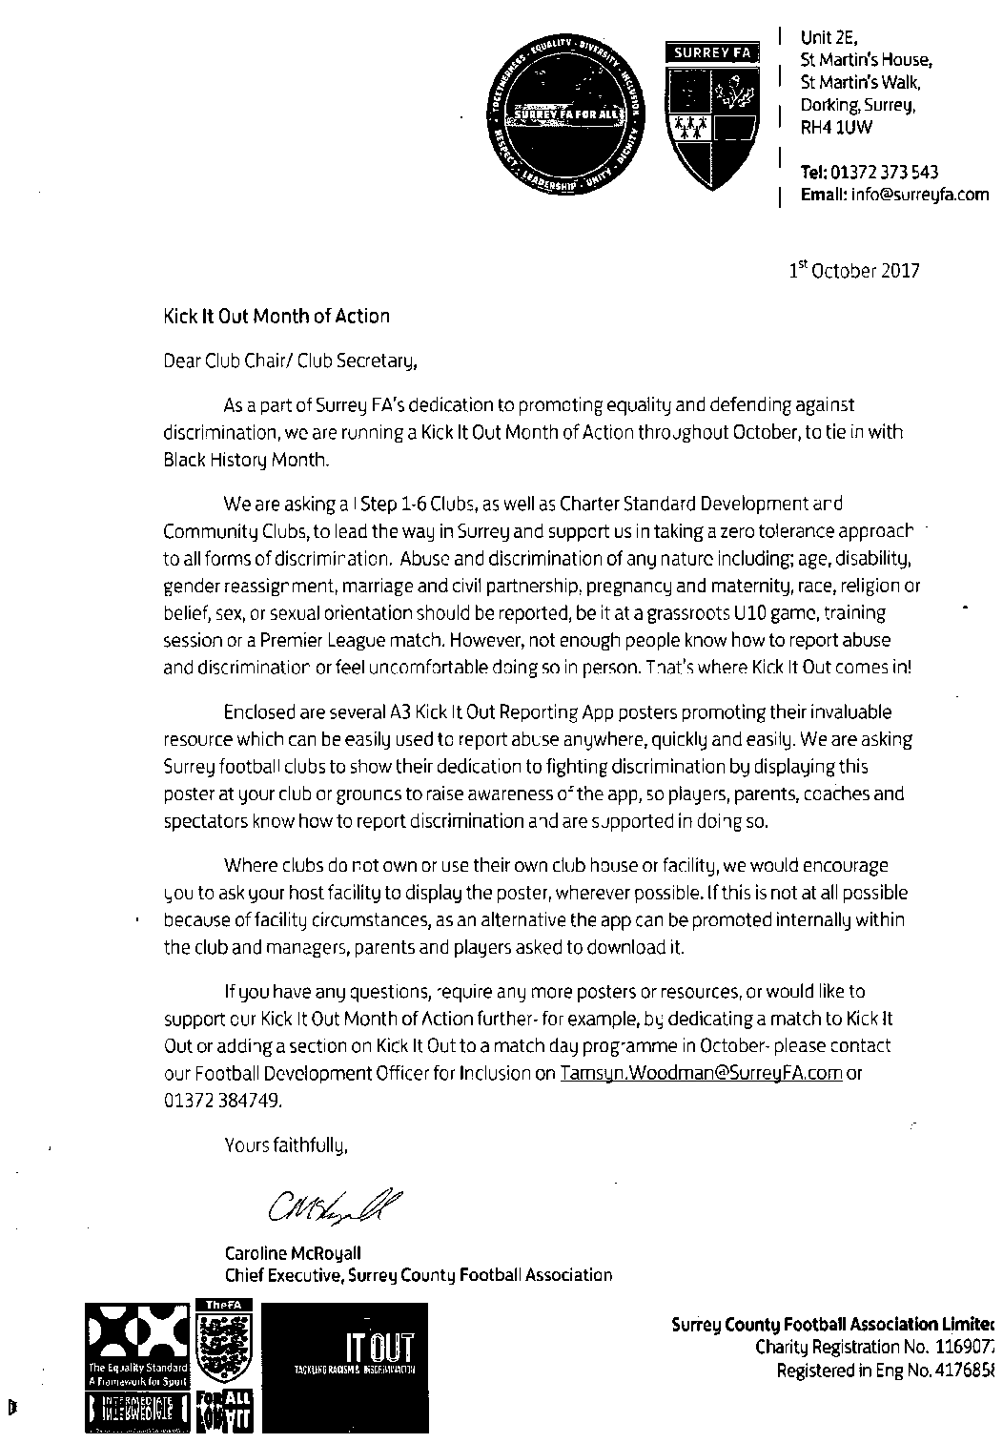

Match and Ball Sponsorships – 2017/18
Opponent | Date | Match Sponsor | Ball Sponsor
Banstead Athletic (FAC) | 06/08/17 | Club President - Stella Lamont
Chertsey Town | 15/08/17 | EEFC Management Committee
Redhill | 02/09/17 | Building Shop Ltd
Spelthorne Sports | 09/09/17 | In memory of Betty Dyke
Horley Town | 12/09/17 | Alex McKay (Senior)
Hanworth Villa | 23/09/17 | Jack Jarman
North Greenford United | 28/10/17
Farnham Town | 14/11/17 | In memory of Dave and Lizzie Marshall
Godalming Town | 21/11/17 | Building Shop Ltd
Guildford City | 02/12/17
Abbey Rangers | 16/12/17
Walton & Hersham | 30/12/17
Balham | 20/01/18
Sutton Common Rovers | 03/02/18
CB Hounslow United | 13/02/18
Knaphill | 24/02/18
Camberley Town | 10/03/18
Bedfont Sports | 24/03/18
Colliers Wood United | 30/03/18
Banstead Athletic | 02/04/18 | Nathan Lambert – 10 years old today!
Westfield | 14/04/18
AFC Hayes | 28/04/18 | Club President - Stella Lamont
Match sponsorship costs just £60.00.

Sponsorship includes:

Admission, programmes and hospitality for three people.

A full page advert in the programme and mascot for the day (if required).

Also, you get to choose the player of the match, who will receive a prize

If you are interested, just speak to a Committee Member,
or drop me an email at: richard.c.lambert@gmail.com

Salts Super Six Predictor
The Salts Super Six Predictor is live again today and the tickets are on sale at today’s game to the left of the gate. The matches are to be played today.

The jackpot is now up to a record high of £630 Can it get any higher? Who knows!

The competition is easy to play! To win, you simply need to predict the results of six matches correctly from the three options, fill in the form and make sure it is back with our seller before the deadline on the ticket. The latest fixtures are shown below.

If you are a club regular, you just need to place your name on the sheet, although if you aren’t, then we’ll need a contact number from you too. We will announce any winners on the website within three working days, so don’t worry, we won’t miss you!

Please note that if there is more than one winner, the prize pot would be shared between the winners. All you need to do now is have a go, as many times as you like!

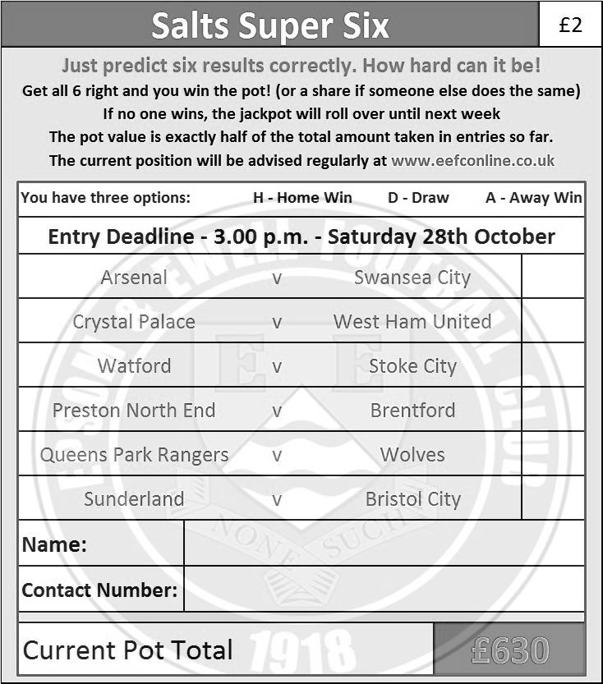

Good luck!

Merchandise
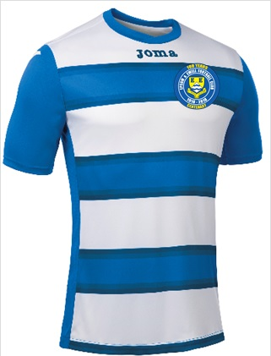
To celebrate our Centenary season we are shortly to have a new kit which will also contain our brand new Centenary badge. We will also be selling polo shirts in either Royal Blue or White.

The costs are being finalised now but if you would like to purchase either a replica new shirt or polo shirts, then let us know and we will get them to you for Christmas or maybe just afterwards. You know where we are!

Be part of the Salts Centenary!

#Saltsfamily

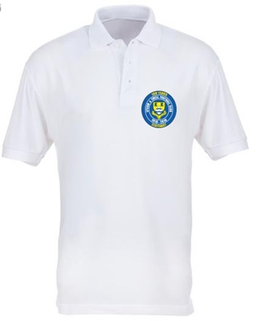
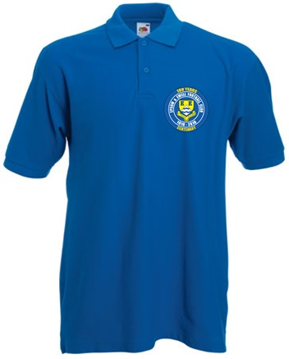

Combined Counties League – Premier Division
Saturday, 28th October 2017 - Kick-off 3.00 p.m.
Epsom and Ewell  (Royal Blue & White hoops) | V |  | North Greenford United  (White / Red / White)
Squad | NUMBERS |  | Squad
Conor Young |  |  | Alex Partridge
Adam Heagney |  |  | Sean Hillier
© Jamie Hatfield |  |  | Ryan Murphy
Reisse Griffin |  |  | Guy Ansah-Palmer
Scott Murphy |  |  | Kamal Akel
Dale Marvell |  |  | Charlie Connor
Liam Roberts |  |  | Nathaniel Mensah
Ashley Thompson |  |  | Daniel Vincent
Kyle Hough |  |  | Brian Testolin
Sean White |  |  | Jordan Ellis
Rob Hendry |  |  | Sandro Costa
Jason Nwachukwu |  |  | Carl Bower
Daniel Rose |  |  | Sammy Adams
Ben Dyson |  |  | Tom O’Regan
Alex McKay |  |  | Stuart Muldrew
Lloyd Connolly |  |  | Ashley Davy
David Thomson
Tayo Ajayi
Jordan Brooks
Ben Hayward
Alistair Turpie
Ali Dewar
Colin Harris
Glyn Mandeville | MANAGER |  | Danny Vincent
Alex McKay | ASSISTANT |  | Terry Schofield
Jimmy Hendry | COACHES / PHYSIO |  | Colin Murphy / Louise Hartley
REFEREE: C.Williams
ASSISTANTS: P.Maskell, D.Olugunna

OUR NEXT VISITORS TO HIGH ROAD
Farnham Town
Combined Counties League – Premier Division
Tuesday 14th November – 7.45pm

